- This work is simply a menu from you to choose work from. There is no pressure to complete this work. It is simply to provide ideas for you if you have time.
- Find what works best for your family in the current situation. A small amount of quality positive learning is more beneficial than a long period of frustration.
- Exercise and play are equally important for your child’s development so try to include these on a daily basis.
- We have focused on English and Maths as we feel it will be best to focus on these two key areas.
- Carry on with your assigned homework if possible.

Maths
This week our focus is place value. Have a go at these questions:

We will also be learning how to round numbers to the nearest hundred. Try these rounding questions below. We have included a photograph of the hundred square that we have been using in class – this will remind you how to round.
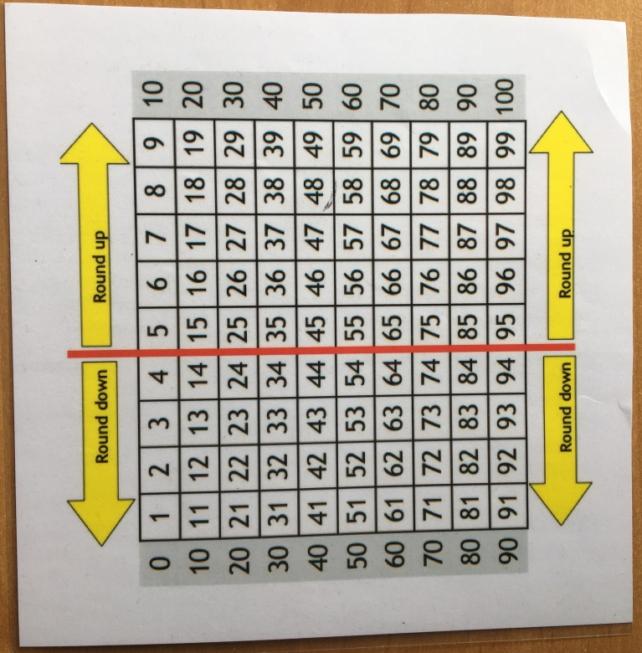

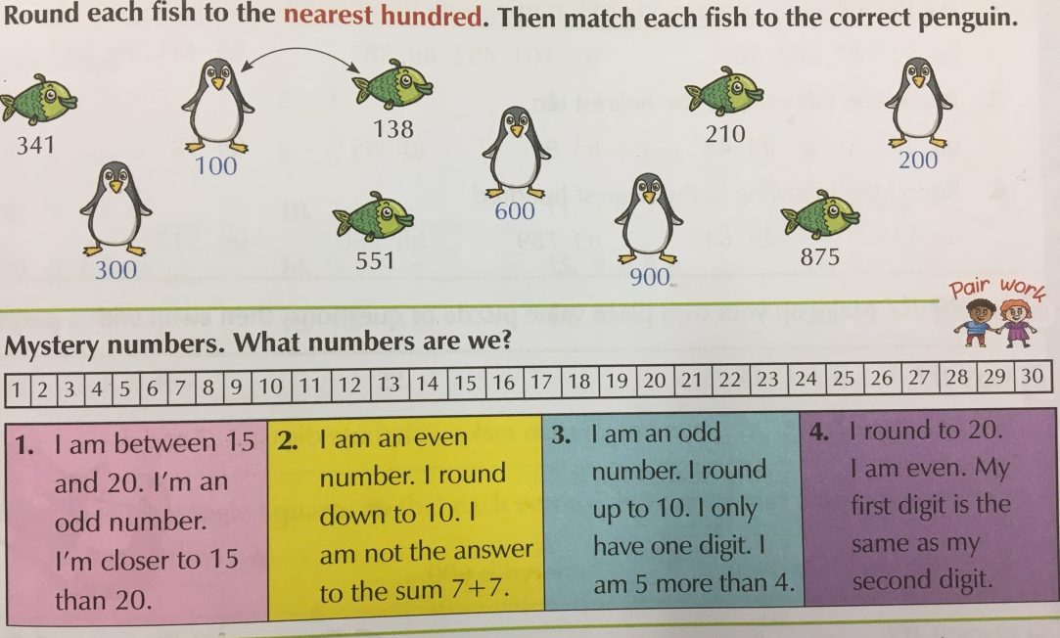
Reading
Remember that it is really important to read a few pages of your home reader each day.

This is our VIPERS text we will be exploring together this week in class.

Have a go at completing this reading comprehension.

Writing
This week we will be exploring recount writing. Recounts are written in the past tense, and tell the reader about an event/s. We use time connectives to tell the reader when something has happened. Have a go at this time connectives activity.

Match up the sentences.

