1st Class Ideas week 30th March- 3rd April 2020
Sample timetable
Monday | Tuesday | Wednesday
Maths  Addition of double digits e.g 56  +31  https://www.khanacademy.org/math/arithmetic/arith-review-add-subtract/arith-review-add-within-100a/v/addition-with-regrouping  or choose a different activity below. | Maths  Word problems- choose one from below. | Maths  Word problems- choose one from below.
English  Phonics: See worksheets below- choose any 2. | English  Grammar: Rhyming words- select one of the activities below.  https://www.twinkl.ie/resource/roi-l-53985-rhyming-words-activity-sheet  or choose a different activity below. | English  Writing: Draw/Write a procedure on how to make a jam sandwich.  - Title  - List the materials needed.  - Use sequence words-first, next, then, after, finally
Choice activity  1. Tidy your bedroom  2. Watch RTE 2 school programme at 11am  3. Choose a gonoodle (youtube)  4. Complete one page in your big handwriting book. | Choice activity  - Art- draw a picture (funny face)  https://www.youtube.com/watch?v=m5YGfmf-AvA  - Choose a Cosmic Kids Yoga (youtube)  - Play outside.  - Make a card for someone you haven’t seen lately (granny, grandad, uncle, friend) and tell them your news. | Choice activity  - Complete one page of handwriting.  - Do 10 hops, 10 jumps, 10 arm twists, 10 arm circles.  - Look out the window and draw a picture in your red copy of what you see.  - Complete one page in your Maths Challenge.

Thursday | Friday
Maths  Time-  Look at the clock.  Read the time at o’clock.  Draw the hands on the clock to show a given time.  Draw something you would do in the morning/ noon/evening/night.  (these links might be useful)  https://www.twinkl.ie/resource/t-n-7132-telling-the-time-powerpoint  https://www.twinkl.ie/resource/t-n-5481-make-a-clock-face-activity | Maths  Complete a Maths Challenge (next page)  Play daily 10 using the link below (select Level 1, addition, up to 20- addition ones)  https://www.topmarks.co.uk/maths-games/daily10
English  Comprehension: choose one comprehension from below.  https://www.twinkl.ie/resource/za-t-l-51740-roald-dahl-differentiated-reading-comprehension-activity  or choose a different activity below. | English  Cloze procedure:  https://www.twinkl.ie/resource/t-t-2547267-cloze-procedure-about-giraffes-activity-sheet - all about giraffes
Choice activity  - Carry out an act of kindness for someone in your family.  - Play a board game - snakes and ladders, jenga, chess etc.  - Play outside.  - Write as many facts you can remember about desert animals. | Choice activity  - Watch an Irish show from Cula4 https://www.cula4.com/en/shows/  - Make up a new game and write the instructions in your red copybook.  - Make a jigsaw.

Homework
Spellbound | Week 28- continue to complete as usual (Monday- block 1 & exercise 1, Tuesday- block 2 & exercise 2, etc.)
Handwriting | Continue to choose three words from the back of Pirate Spelling Record Book and put the words into sentences.
Tables | 8+ tables
Reading | Use the links below to access reading books.  - Epic https://www.getepic.com/  - International Children’s Digital Library http://en.childrenslibrary.org/  - Amazon’s Free Kids Ebooks https://www.amazon.com/Best-Sellers-Kindle-Store-Childrens-eBooks/zgbs/digital-text/155009011/ref=zg_bs?_encoding=UTF8&tf=1  - Barnes & Noble Free Nook Books for Kids https://www.barnesandnoble.com/b/free-ebooks/nook-books/kids/_/N-ry0Z8qaZtu1

- The work I have sent is merely a menu, a list of suggestions. Please do not feel under pressure to complete the work.
- In some areas I have provided a selection of worksheets under the same topic. This is so your child can choose a level that suits them, for example, there may be two comprehensions- your child can choose one.

English- Monday (choose two activities)
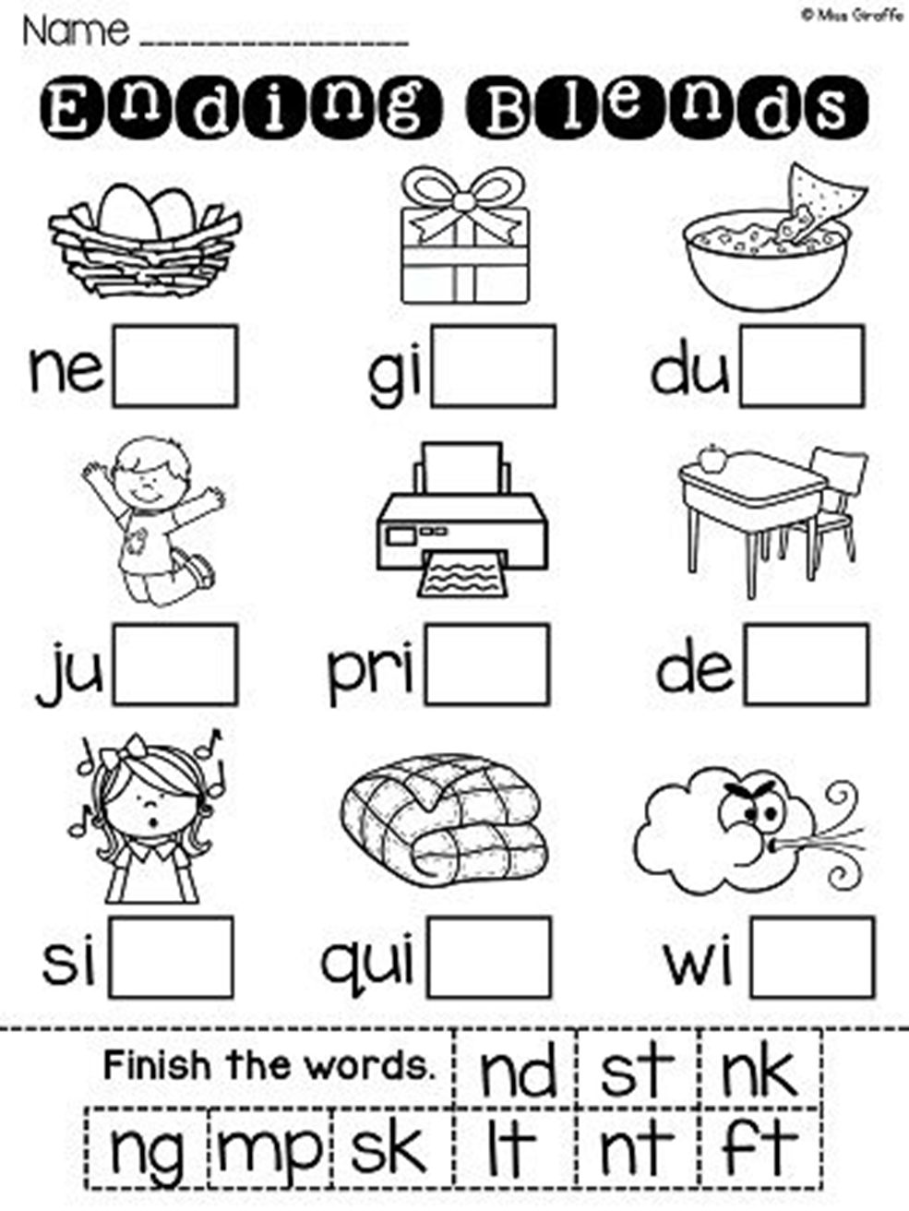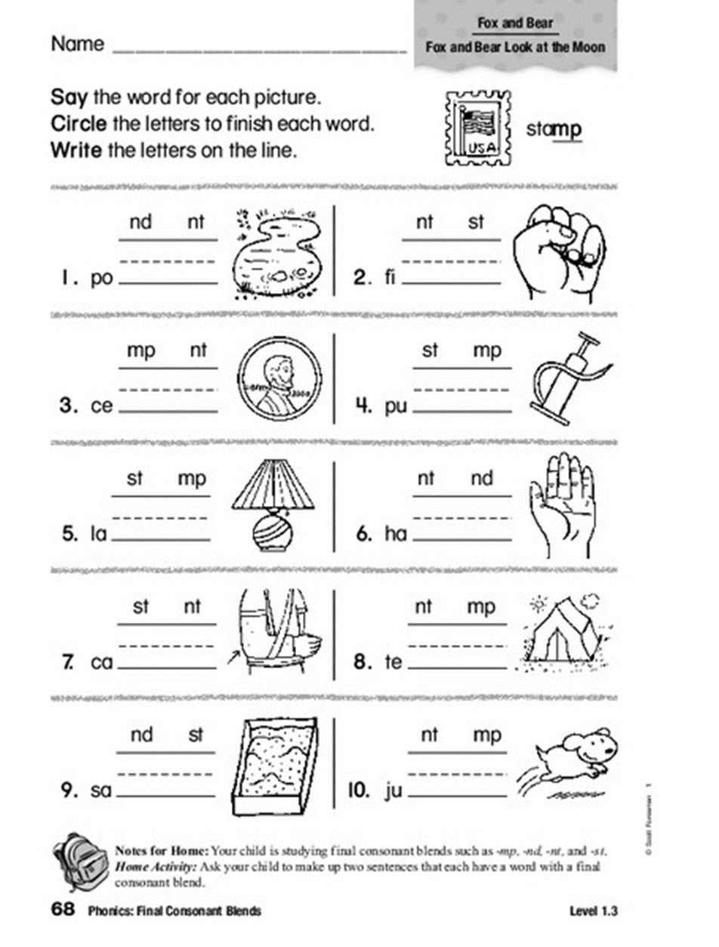
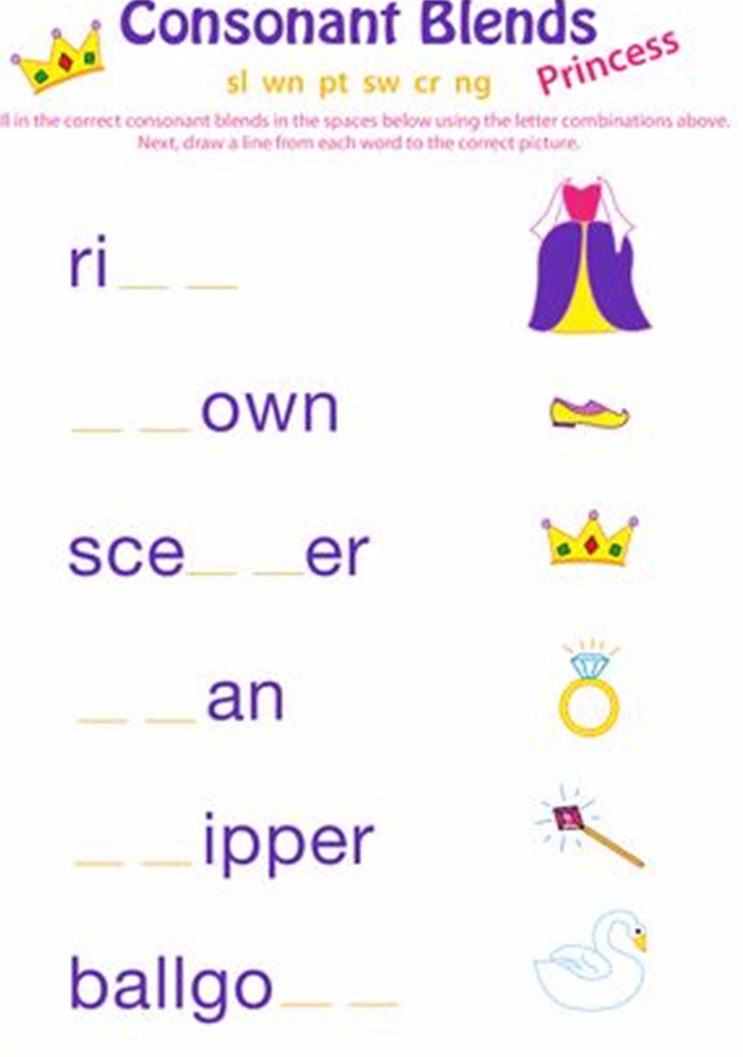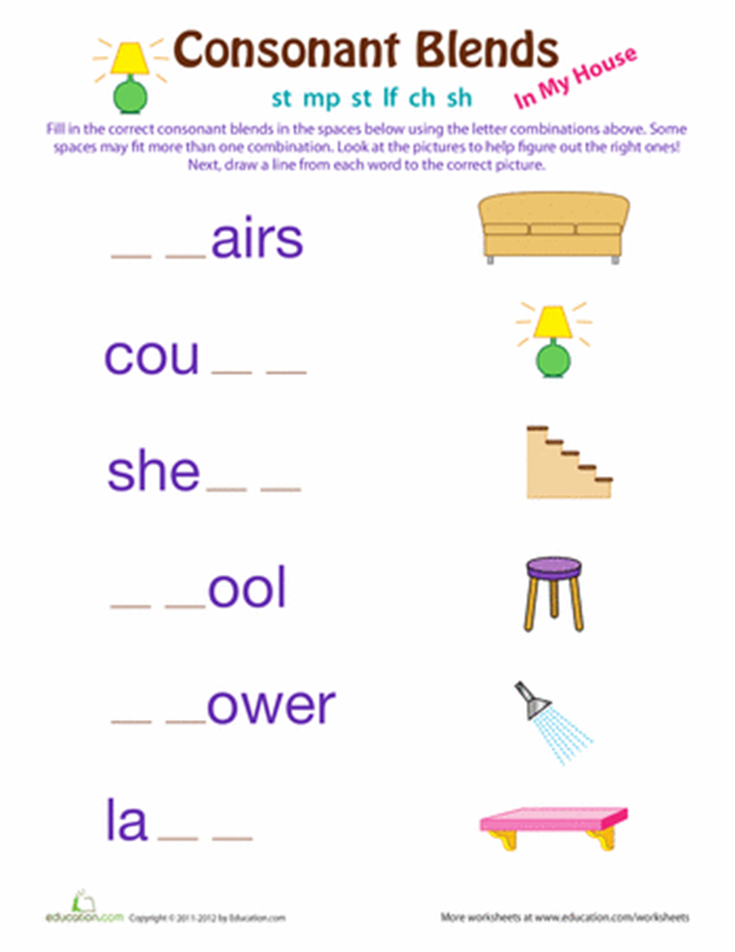
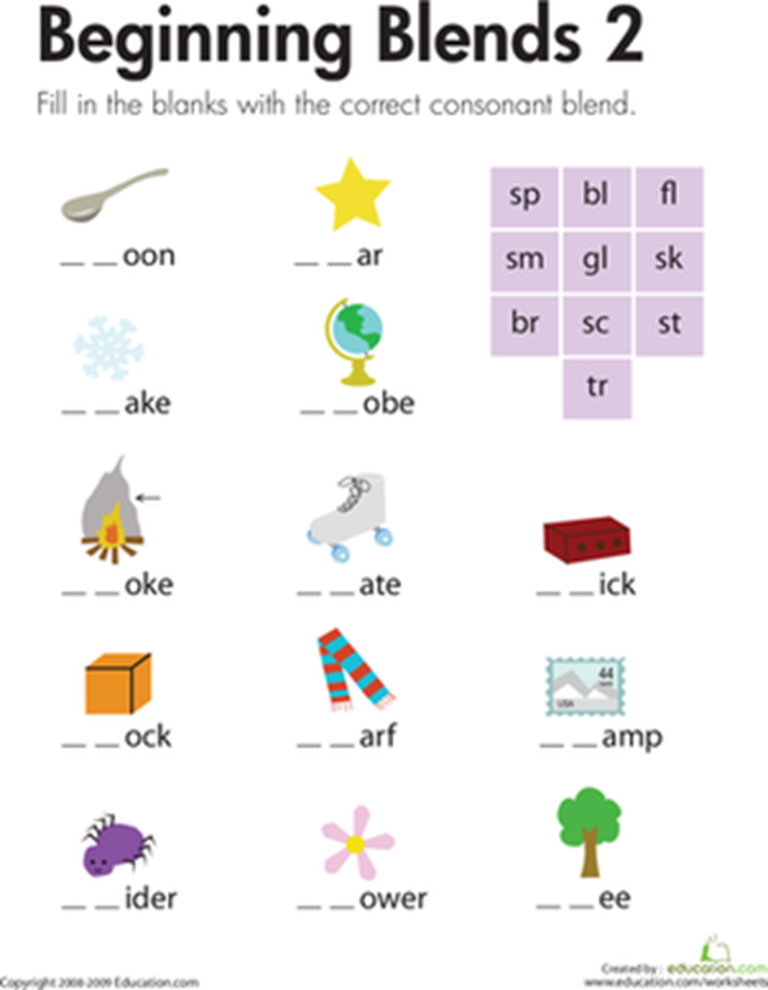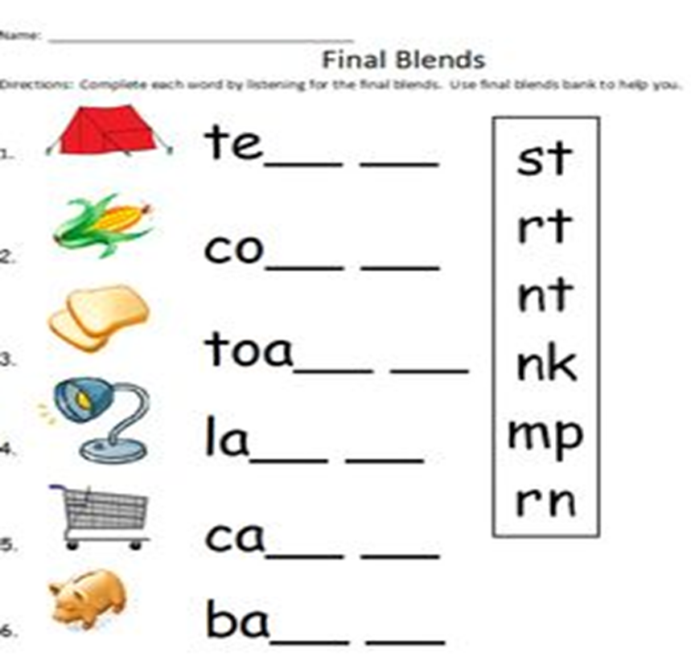
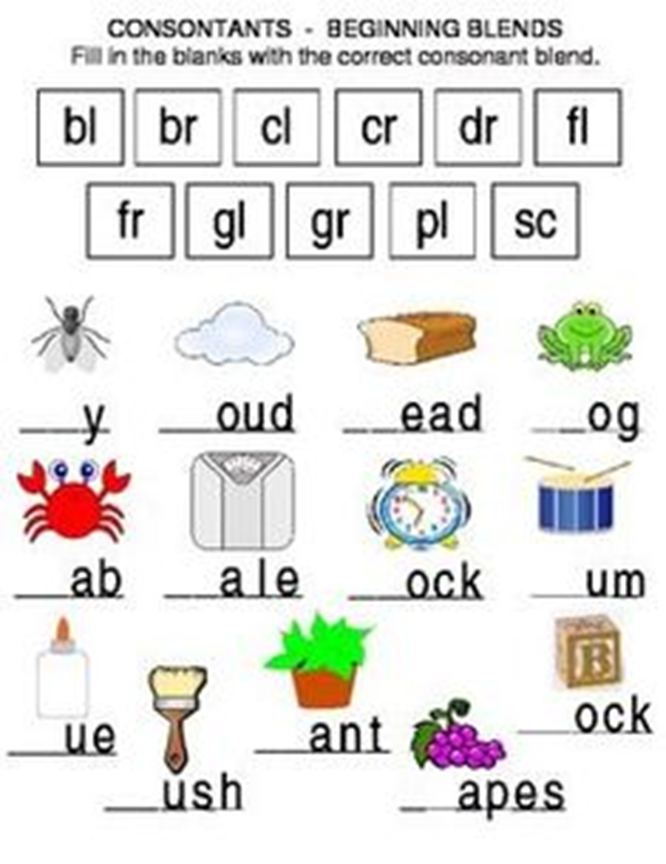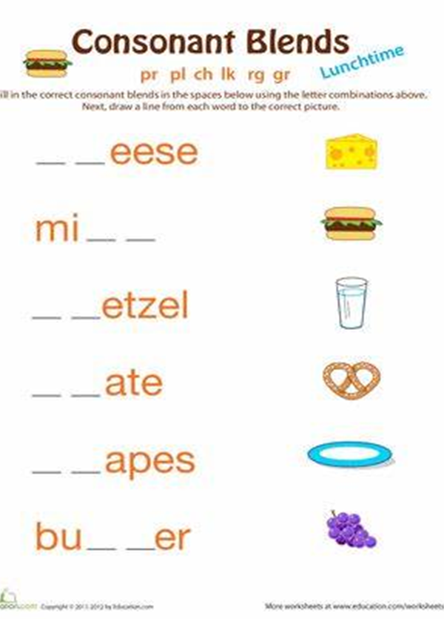

English choice activity (Tuesday) English choice activity (Thursday)
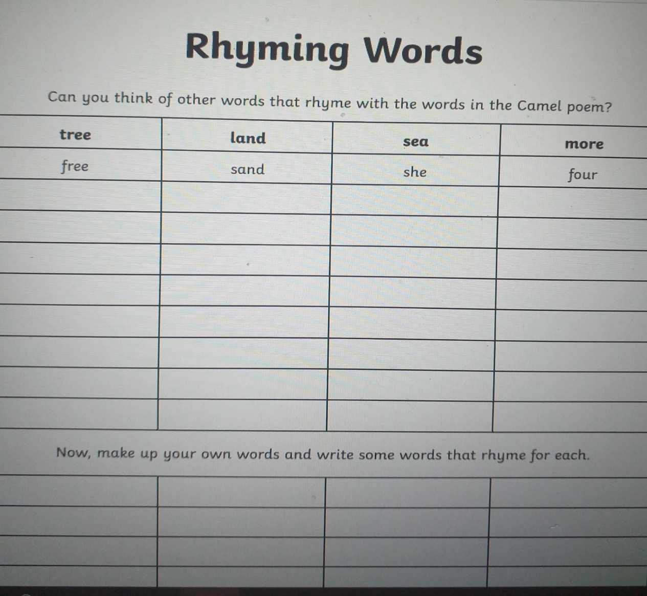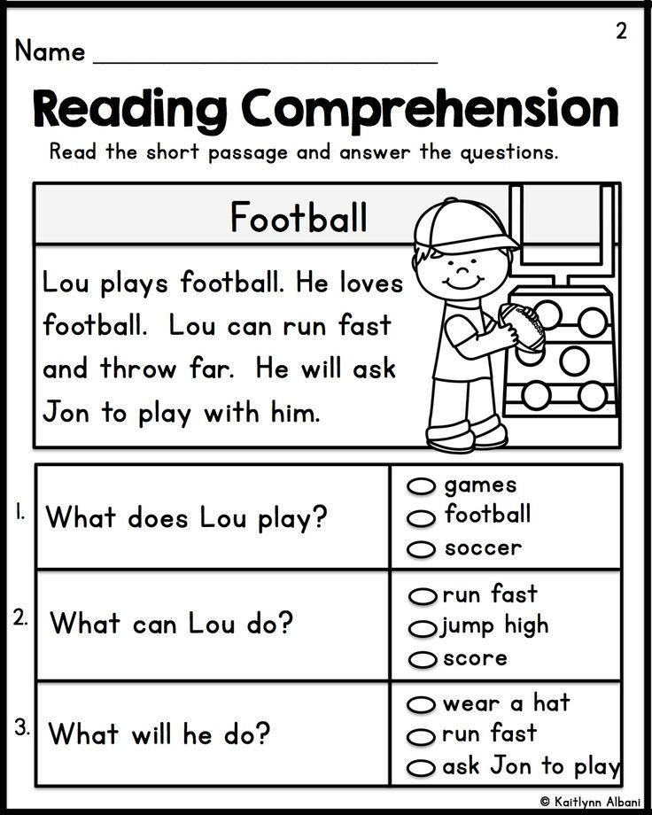
Monday (choice activity- choose one of the four activities)
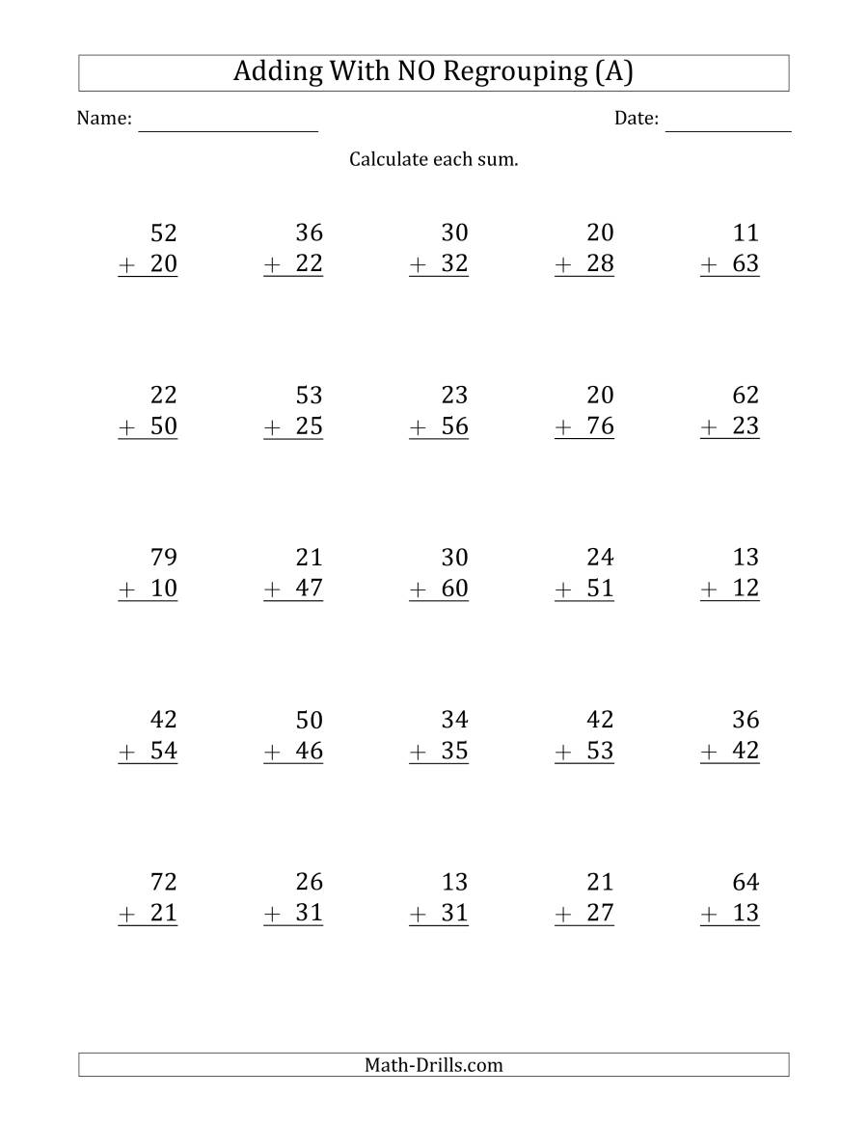
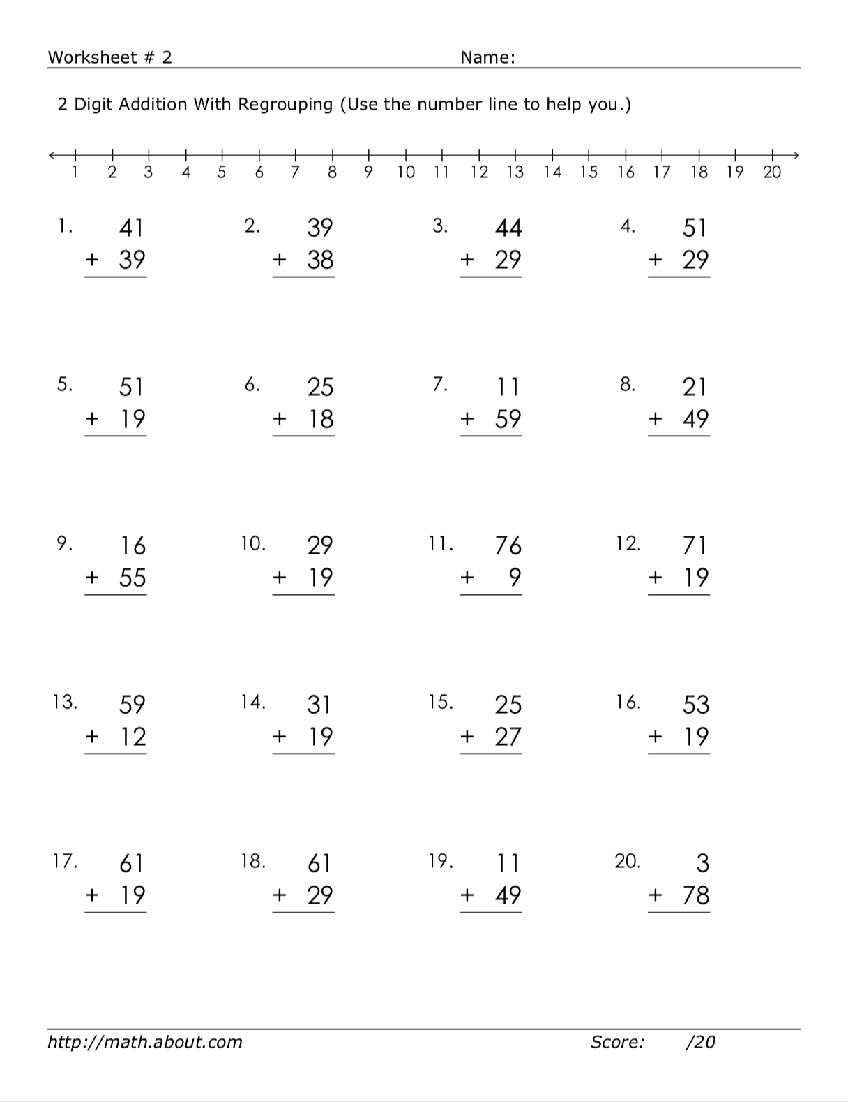
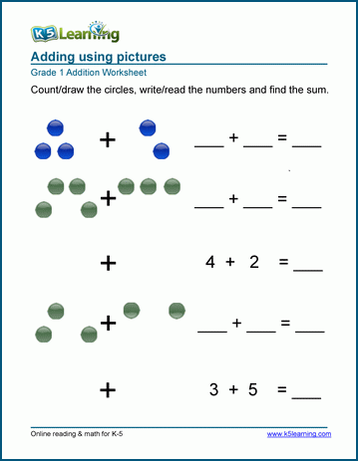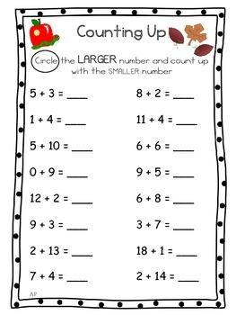
Tuesday & Wednesday (choice activity- choose one of the activities on Tuesday and another on Wednesday)
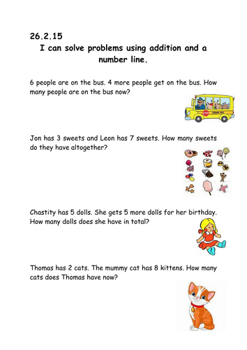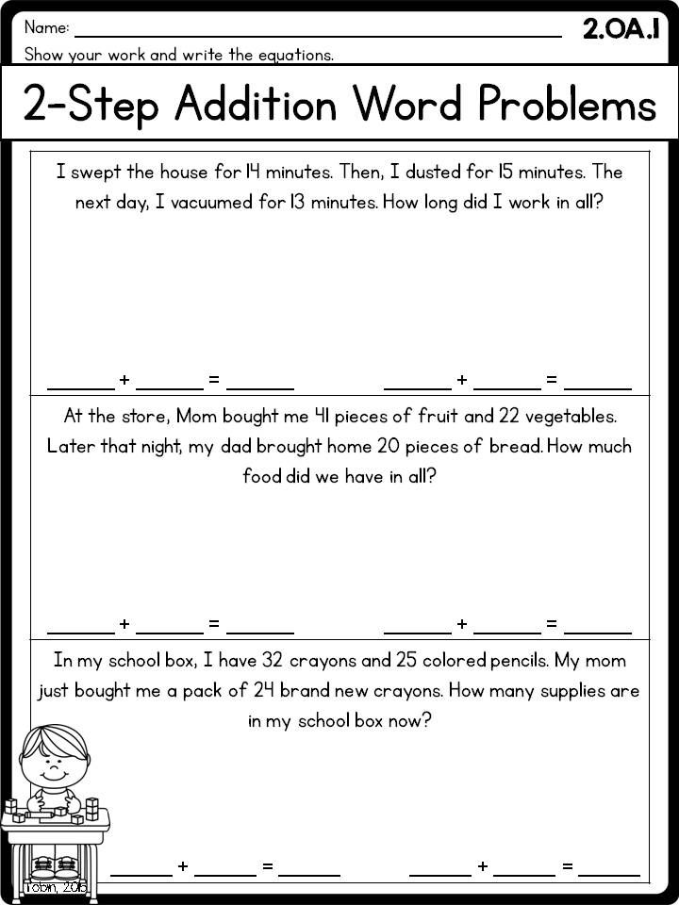
1. I bought a bag for 35c and another for 42c. How much did it come to?
2. I have 52 red books and 89 green books. How many books do I have?
3. In a small school there are 138 girls and 59 boys. How many children are there in total?
4. As a teacher I buy 91 pens and 99 pencils a year. How many pens and pencils do I buy?
5. In 3rd Class there were 87 children and in 4th Class there were 92 children. How many children were in 3rd and 4th class?
6. In a car park there are 75 red cars and 125 blue ones. How many cars are there?
7. 158 children are watching a football match. 27 more children come to watch. How many are now watching the match?
8. If we have 69 tennis balls, 87 footballs and 91 rugby balls, how many balls do we have?
9. In my wallet I have 22c, in my pocket I have 49c and in my pot at home I have 75c. How much do I have in total?
10. In a car park there are 150 red cars, 65 blue ones and 107 green cars. How many cars are there?

Thursday (choose of the following activities)
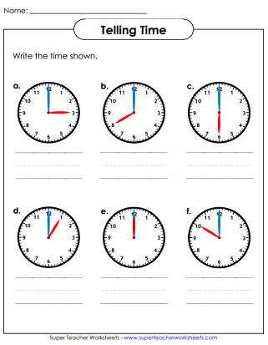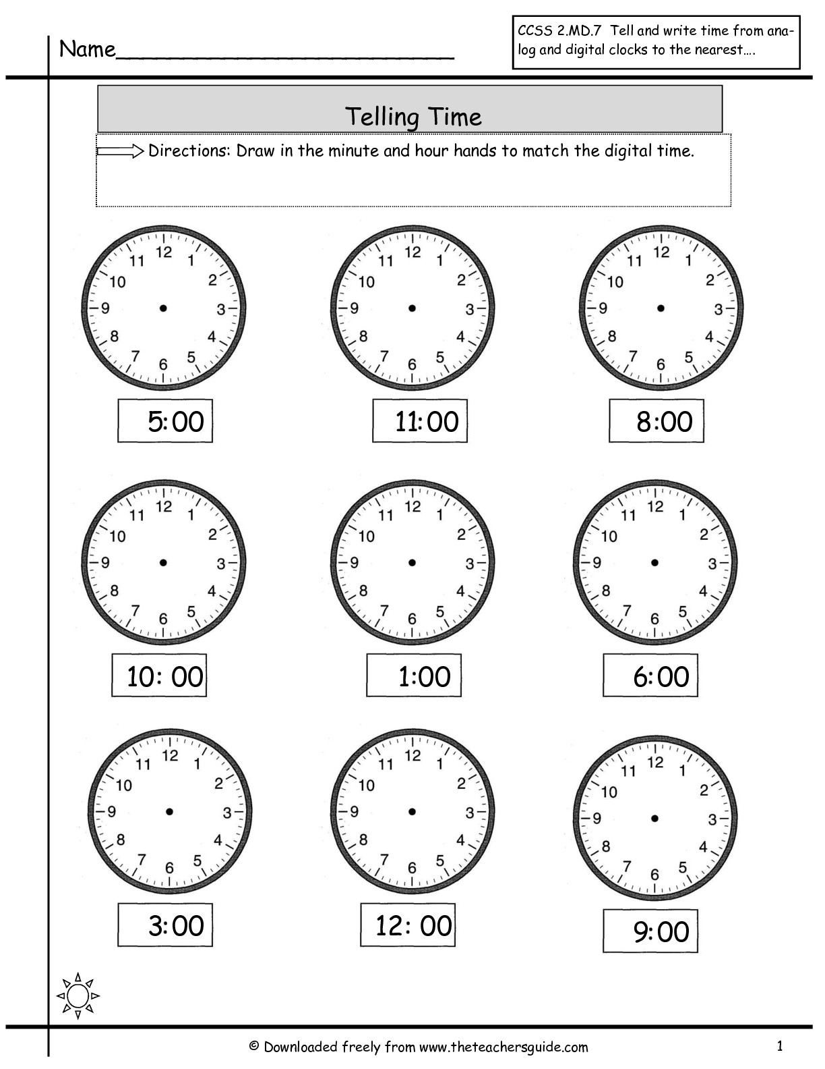
or https://mail.google.com/mail/u/0?ui=2&ik=6f1ca01ce8&attid=0.2&permmsgid=msg-f:1661956164607850010&th=1710745387b8b61a&view=att&disp=safe&realattid=171072f16b2c915da862

