4th Class home learning: 05/10/20 - 09/10/20
· This work is simply a menu from you to choose to work from. There is no pressure to complete this work. It is simply to provide ideas for you if you have time.
· Find what works best for your family in the current situation. A small amount of quality positive learning is more beneficial than a long period of frustration.
· Exercise and play are equally important for your child’s development so try to include these on a daily basis.
· We have focused on English and Maths as we feel it will be work best to focus on these two key areas, please let us know if you would like ideas for other areas.
Please scroll down below this table to find further information on this weeks work.
English writing | Procedural Writing:  Playground game: Write a procedure on how to play a playground game of your choice e.g. hopscotch, cops and robbers.  If you scroll down the page, you will find  - A picture which explains procedural writing  - An template which can be used to help your child to write a procedure.  There are 4 steps to writing a procedure. Try to include:  - The aim  - Materials/ ingredients needed.  - Numbered steps.  - Evaluation. Did it work? Would you do it different next time?  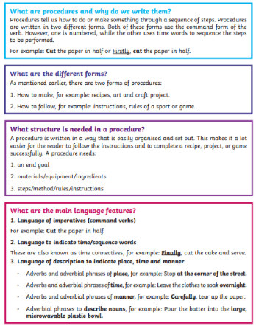  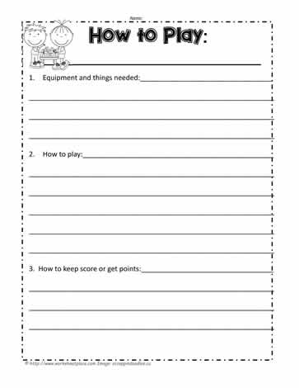  Spellbound: Week 6
English reading | Read daily for pleasure for 30 minutes. Complete daily reading tasks. Here are some examples:  - Persuasive piece: Reading is so important for all kids. Write a persuasive argument that you could read to children in the Infant Classes of our school to make them even more interested in reading.  - Report Card: Pretend you are the teacher of a character in your book. Write an end of year report for that student.  - Fast facts: Choose 10 facts to describe a character in a book or the plot of a book.  - Make a Wish – Do you wish events in a story happened in a different way or had a different outcome? Share your thoughts about what you WISH would have happened.
Maths | Tables: x8 ÷8  Multiplication:  Monday  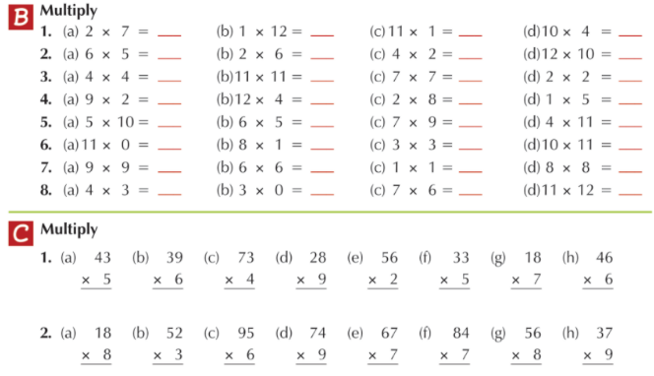  Maths: Tuesday  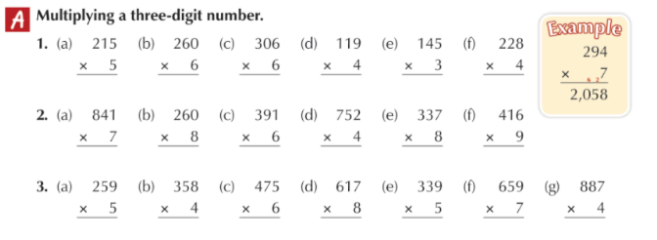  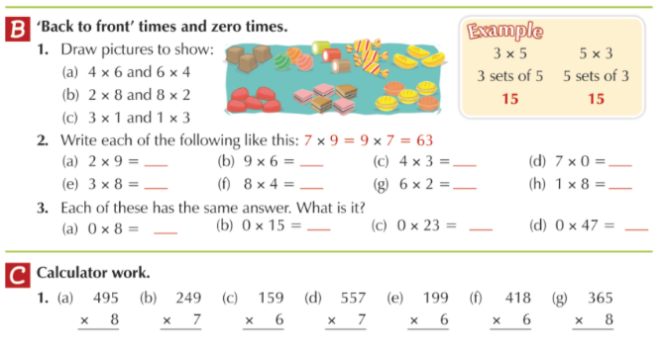  Maths: Wednesday  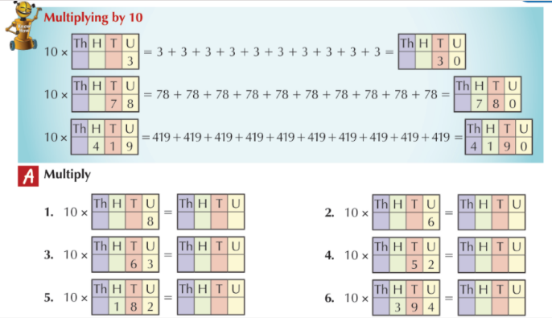  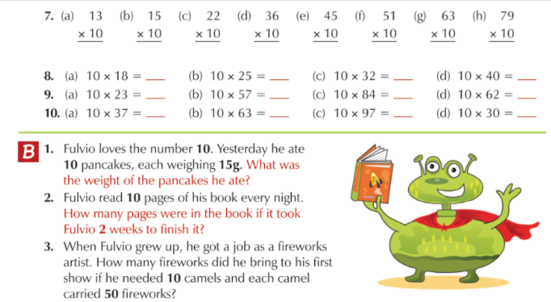  Maths: Thursday/ Friday  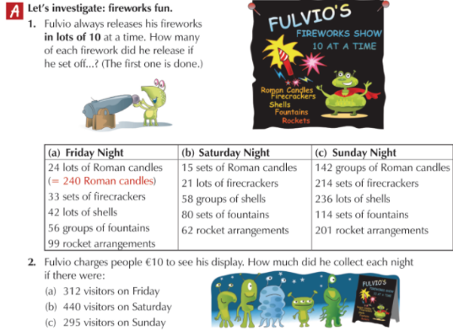  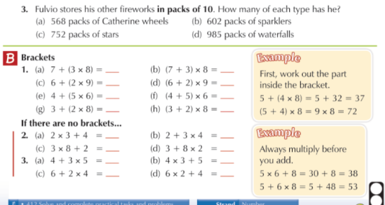
SESE/ Project work | Counties of Ireland  - Complete the worksheet below.  - Do a project on a county of your choice. Include:  - Province and Location  - Population  - County Colours  - History of the county  - Famous landmarks  - Famous people from the county  - Design your own GAA jersey for the county. Use the blank jersey below.  