4th Class home learning: 28/09/20 - 02/10/20
· This work is simply a menu from you to choose to work from. There is no pressure to complete this work. It is simply to provide ideas for you if you have time.
· Find what works best for your family in the current situation. A small amount of quality positive learning is more beneficial than a long period of frustration.
· Exercise and play are equally important for your child’s development so try to include these on a daily basis.
· We have focused on English and Maths as we feel it will be work best to focus on these two key areas, please let us know if you would like ideas for other areas.
Please scroll down below this table to find further information on this weeks work.
English writing | Procedural Writing:  Write a procedure on how to make a recipe of your choice.  For example, you could write a procedure about how to make a raspberry cheesecake.  If you scroll down the page, you will find  - A picture which explains procedural writing  - An example called “How to Make Bread”  There are 4 steps to writing a procedure. Try to include:  - The aim  - Materials/ ingredients needed.  - Numbered steps.  - Evaluation. Did it work? Would you do it different next time?  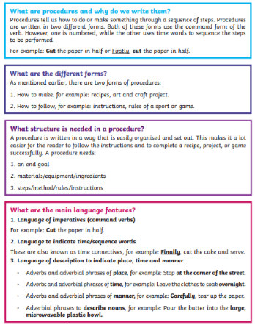  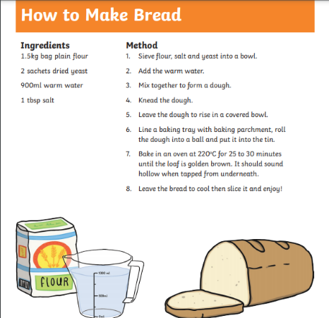  Spellbound: Week 5
English reading | Read daily for pleasure for 30 minutes. Complete daily reading tasks. Here are some examples:  - Word finder - Find five interesting or difficult words from the text. Find the dictionary meanings and put them into sentences.  - Character Artist - Draw a picture of the main character/s in the book. What image do you have in your head of the character? Find a passage in the text that describes them to help you.  - Comic Artist - Do you think your book could be rewritten/ redrawn as a comic? Give it a go using pictures to help you (Note: This can be done over the course of the whole week!)  - This is Important - Write down the most important events that have happened in the story (so far). If you are only starting a new book, choose a book you have read previously. Why were they important to the text?
Maths | Tables: x4 ÷4  Time:  Monday  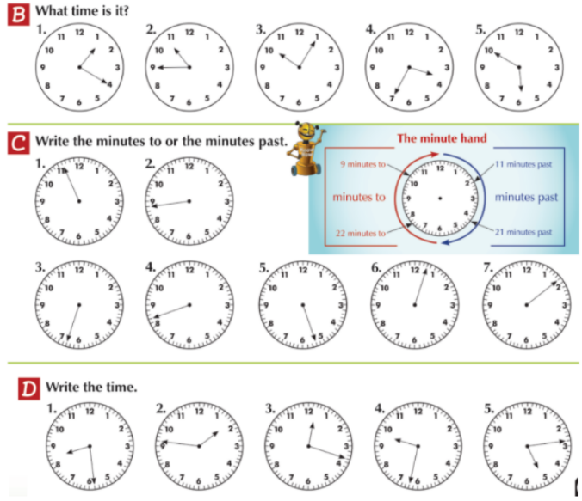  Maths: Tuesday  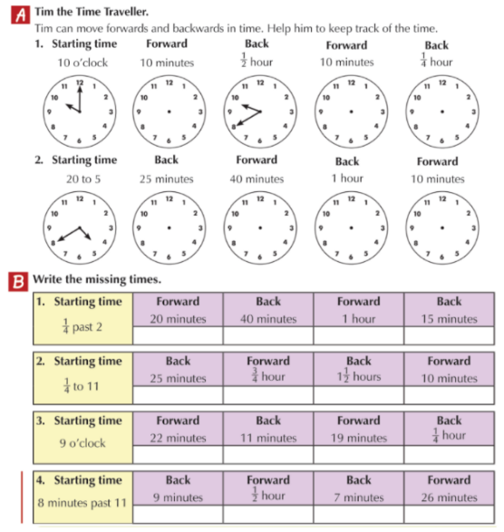  Maths: Wednesday  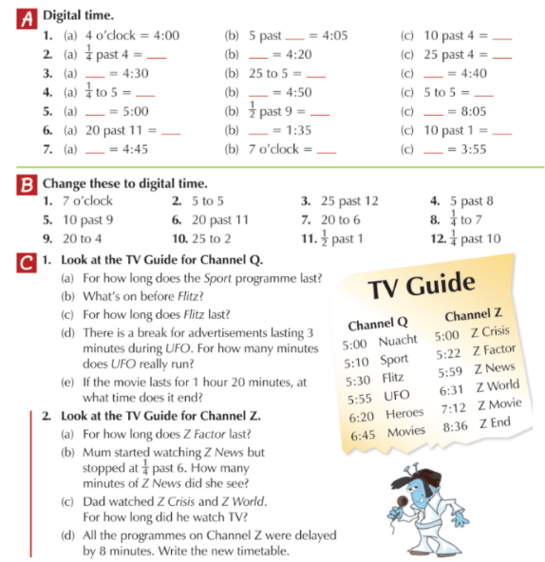  Maths: Thursday/ Friday  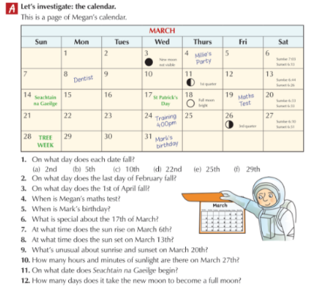
SESE/ Project work | Looking after your teeth. Answer the following questions.  - How can we look after our teeth?  - List reasons why need to look after our teeth.  - Write a procedure of how to brush your teeth. Draw and label a picture at each step.  - Complete the worksheet below identifying each tooth. Write the function of each tooth.  