Activities for your Child to do – Ghana Class (Optional)
Print out this chart so that children can colour the activity they have completed. :)

Read a book aloud to your parents or siblings | 30 minutes physical activity | Clean and tidy your room. | Play a Game of Snakes and Ladders – see Weekly Tasks 2. | Draw a picture using Art Hub for kids - Step by Step Drawings
Go on a nature walk | Play the Money Game App on the Ipad. | Make a phonecall to a family member or friend and ask them 3 questions about their day. | Write a procedure – How to Make Pizza | Help to clean up after meals.
Have a Movie Night with your family. | Make your bed in the morning. | Play a game of Kahoot – check out the class padlet! | Play the Reading Eggs App | Take a picture of you engaging in your favourite activity and put it on the padlet for all your friends to see.
Send an An Post Free Postcard to a loved one. | Eggy Characters – Make your own character out of eggs.  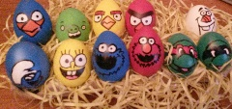 | Write a short Recount on the Class Padlet telling your friends about your day. | Rainbow Hunt  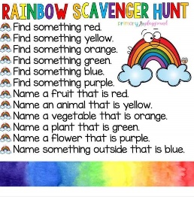 | Write a procedure – How to Make Popcorn
Count aloud to 100. | Write a procedure – How to play Follow the Leader. | Take the Daily 10 Challenge every day for a week!  https://www.topmarks.co.uk/maths-games/daily10 | Try a new fruit or vegetable every day for a week. | Make a jigsaw.
Have Lots of FUN!!!

Please ask your mum or dad to send on any pictures of your work via email or you could post it yourself through the ‘Padlet’ app!!!

Stay safe, Stay home!

