Week 3: 1st Class 14th – 18th September
Homework
English | - Spellbound Week 2  - Read, write, spell words: (use the look, say, cover, write, check approach)  Monday: as, asked, at  Tuesday: back, be, big  Wednesday: but, by, called  Thursday: came, can, children  - Home Reading
Maths | - Tables +2 sheet

Optional Home Learning Table

English | - Recount: Read a story to your child (any short story/ fairytale). Ask them to retell you the story using the heading in the template below. If possible they could fill in the plan one day and the following day they can use their plan to rewrite the story in their own words. This will take 3/ 4 days to complete.
Maths | - Planet Maths pg. 13, 14, 15, 16 are being done in class this week. Photo of pages attached below.

Tables Homework:
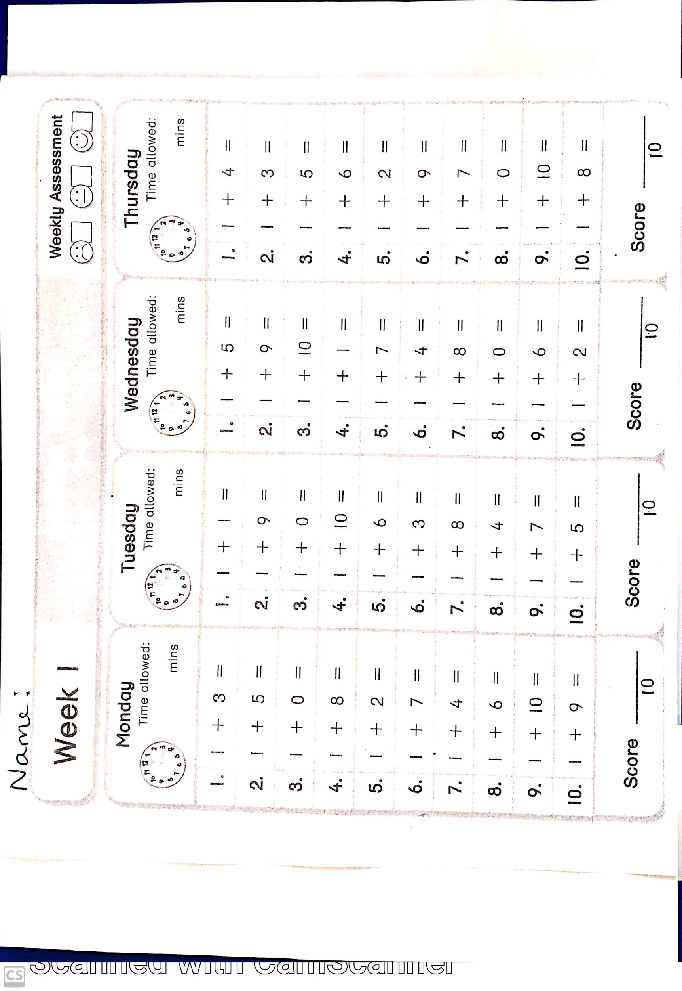

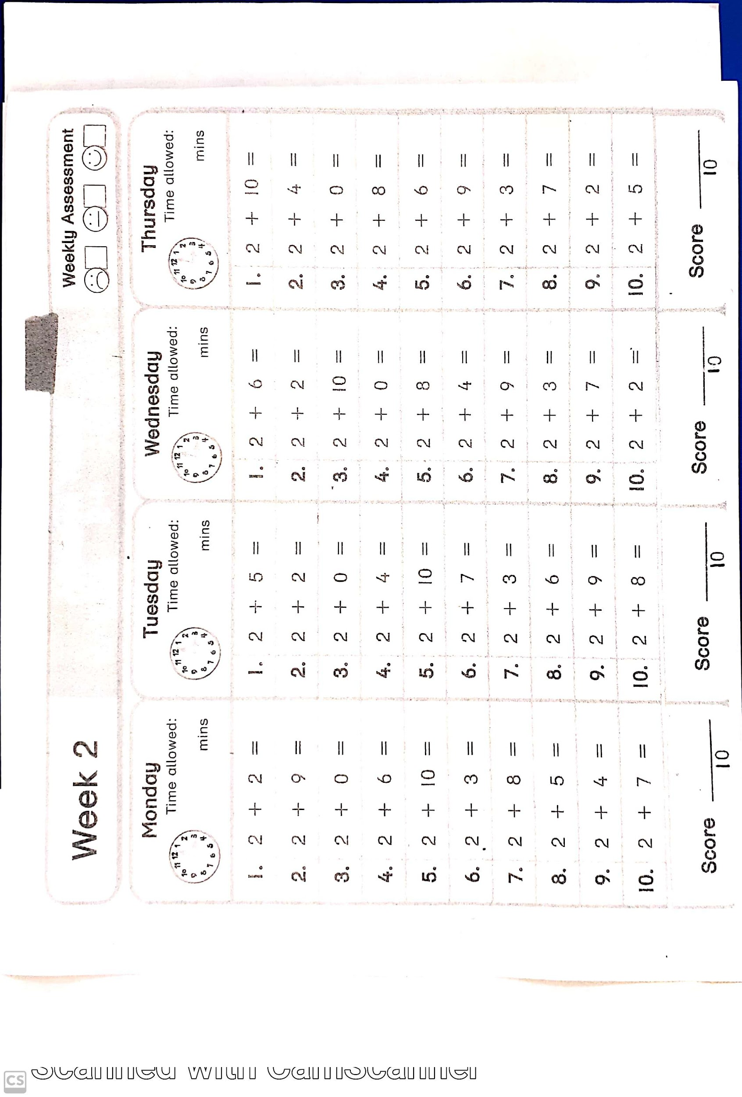

Recount Template: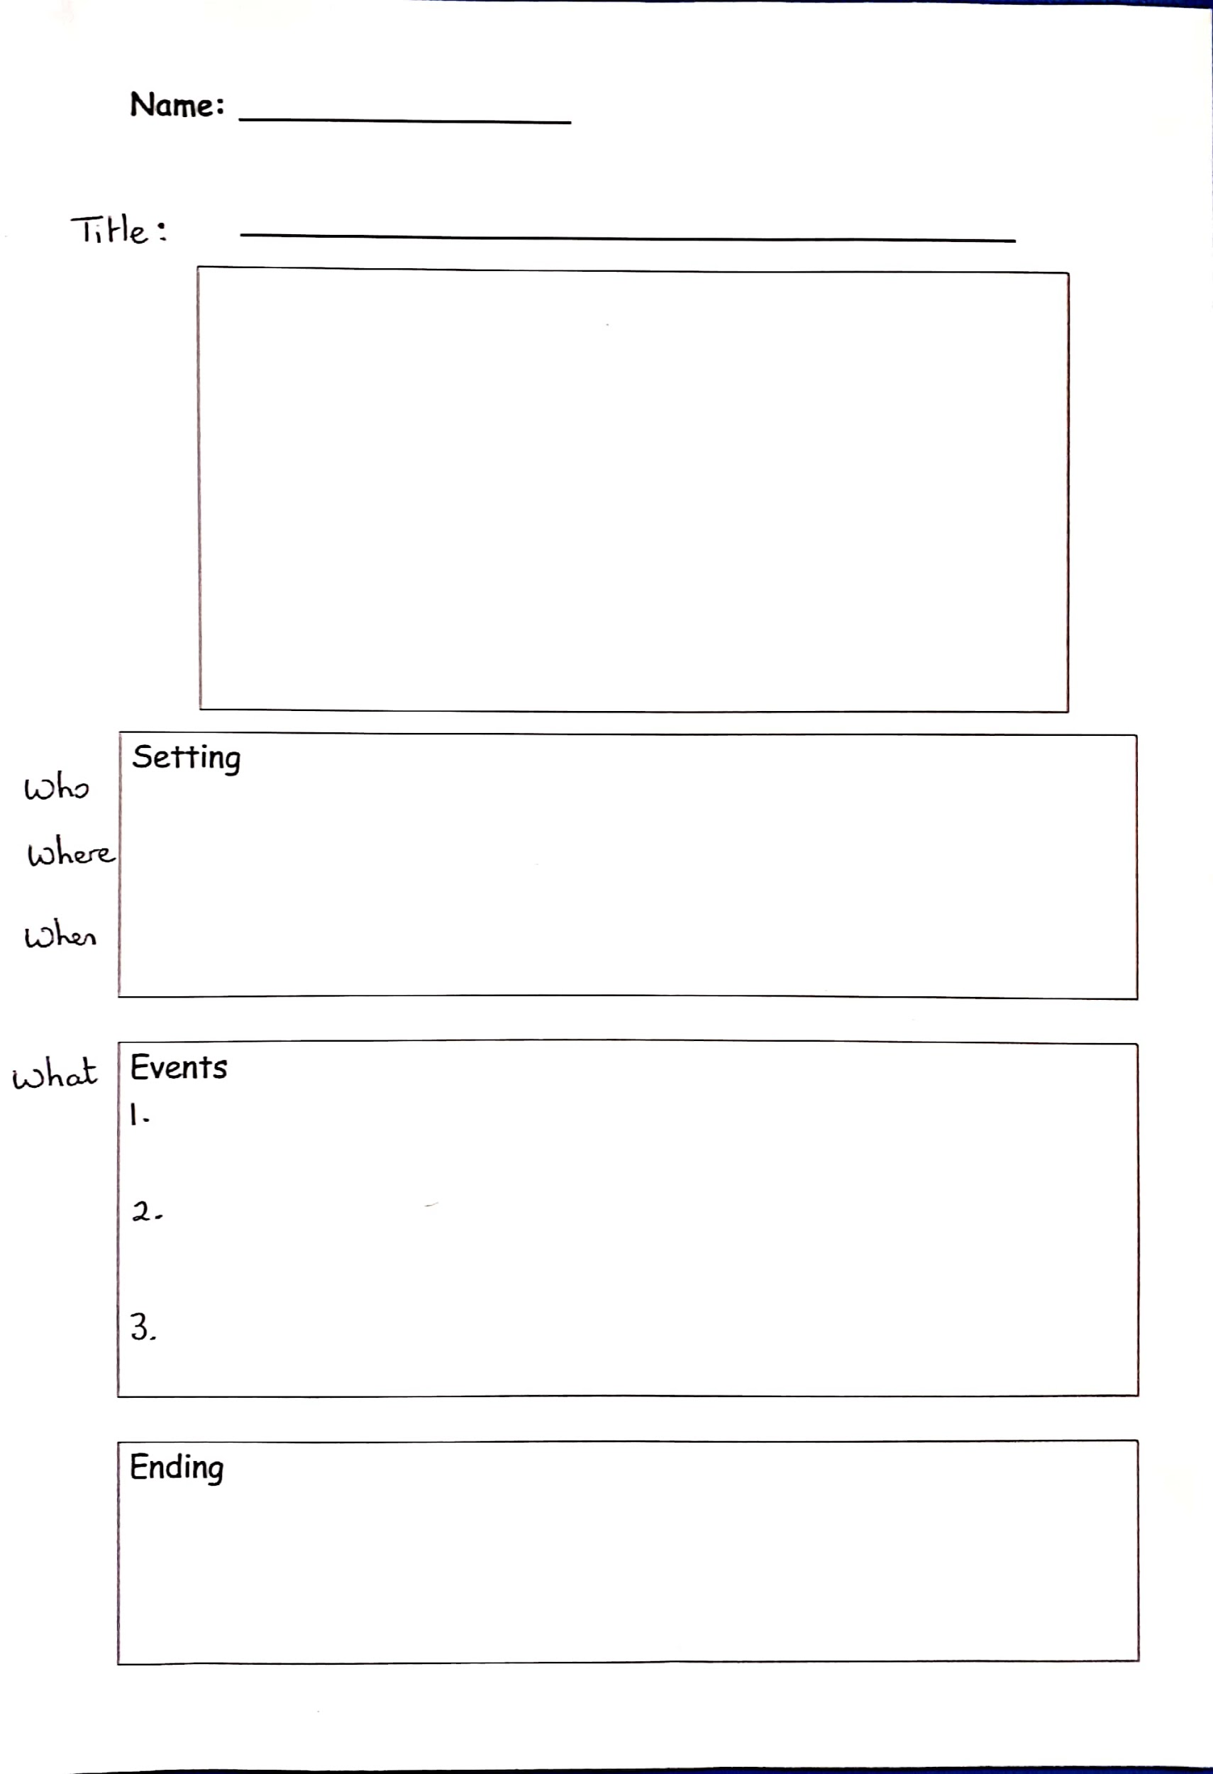

Planet Maths Pages:
