1st Class 21st – 25th September
Homework
English | - Spellbound Week 3  - Read, write, spell words: (use the look, say, cover, write, check approach)  Monday: come, could, dad  Tuesday: day, do, don’t  Wednesday: down, for, from  Thursday: get, go, got  - Home Reading
Maths | - Tables +3 sheet

Optional Home Learning Table

English | - Recount: Recall an event that you experienced with your child (birthday, holiday etc.). Ask them to describe the details using the headings in the template below. If possible they could fill in the plan one day and the following day they can use their plan to rewrite the event in their own words. This will take 3-4 days to complete.
Maths | - Please see pages attached below.

Tables Homework:
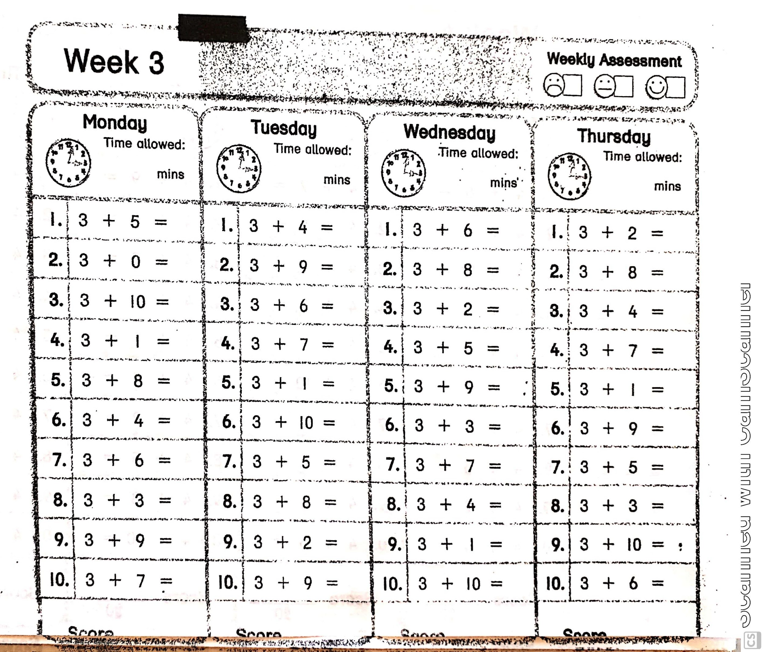

Recount Template:
