**Week- April 27th - May 1st**

**Any questions please contact** [**colm@lucaneastet.ie**](mailto:colm@lucaneastet.ie) **or** [**ciana@lucaneastet.ie**](mailto:ciana@lucaneastet.ie) **or** [**fiona@lucaneastet.ie**](mailto:fiona@lucaneastet.ie)

* This work is simply a menu from you to choose work from. There is no pressure to complete this work. It is simply to provide ideas for you if you have time.
* Find what works best for your family in the current situation. A small amount of quality positive learning is more beneficial than a long period of frustration.
* Exercise and play are equally important for your child’s development so try to include these on a daily basis.
* We have focused on English and Maths as we feel it will be work best to focus on these two key areas, please let us know if you would like ideas for other areas.
* Carry on with homework per homework sheet if possible.

|  |  |
| --- | --- |
| **Day** | **Activity** |
| **Monday** | **English:**  **Reading:** Book assigned to your individual child on getepic website-email sent with details of how to log in  **Phonics:** This week focus on the oo sound- <https://www.youtube.com/results?sp=mAEB&search_query=geraldine+the+giraffe+oo>  Long oo sound: <https://www.youtube.com/watch?v=kL074H5XdNI>  Short oo sound: <https://www.youtube.com/watch?v=TdM2LUkBQzk>  Games to help with sound- <https://www.ictgames.com/dinosaurEggs_phonics/mobile/>  **Maths**:  Use book if you have collected this from the school. Otherwise you can access the book for free online at the following link. You will need to register but this is free.  <https://www.folens.ie/news-and-events/parents-teachers-get-access-to-all-our-digital-teaching-materials>  Planet Maths: pg. 103 counting revision  Follow the link for games to play to reinforce this; <https://www.folensonline.ie/home/library/programmes/planet-mathssi/resources/>  **Optional**:   * PE with Joe Wicks – Challenge yourself! <https://www.youtube.com/watch?v=qGKGNzNbWjU&list=PLyCLoPd4VxBvQafyve889qVcPxYEjdSTl&index=6&t=0s> |
| **Tuesday** | **English**:  **Reading:** Book assigned to your individual child on getepic website.  **High Frequency Words revision:** Revise these words: book, boy, but, called, came, can't , children, cold, coming, could.  **Vocabulary work**:  Can you write a sentence using 2 of these words?  Can you say a sentence using each of these words?  **Maths**:  **Planet Maths:** pg. 104 Length Revision  **Game:** <https://content.folensonline.ie/programmes/PlanetMaths/PMSI/resources/activitya/pm_si_104/index.html>  **Optional**:  Gaeilge: Ag Siopadóireacht- Mála nua (Shopping – New bag)  <https://content.folensonline.ie/programmes/AbairLiom/SI/resources/Poster/AL_SI_ACT_Postaer_L18_001/index.html> |
| **Wednesday** | **English:**  **Reading:** Book assigned to your individual child on getepic website.  **Writing** : Recount activity  Can you write your news for this week into a page and send it to my email?  **Maths**:  **Planet Maths:** pg. 105 Length Revision  **Game:** <https://content.folensonline.ie/programmes/PlanetMaths/PMSI/resources/activities/pm_si_105/index.html>  **Optional**:  **SESE: King Midas and the Golden touch**: Watch a video of the story: <https://www.youtube.com/watch?v=7IoF9IrZnXU&t=397s>  OR  Read the story Flip book: <https://www.twinkl.ie/resource/t2-h-4724-king-midas-ebook>    **Activity**: Can you sequence the story OR retell the story and draw a picture from your favourite part?  Sequence sheet at the end of the page. |
| **Thursday** | **English:**  **Reading:** Book assigned to your individual child on getepic website.  **Revise ug words**- rug, bug, hug, mug etc.  **Starfall game**: <https://www.starfall.com/h/ltr-sv-u/maw-ug/?t=291102606>  Song to help with this- <https://www.youtube.com/watch?v=ByHwuuAsEmo>  **Maths**:  **Planet Maths:** pg. 106 Length  Nonstandard measurement video : <https://www.youtube.com/watch?v=q8o7n-A0SC0>  **Optional**:  Music: You are my Sunshine: Learn the song from Padlet options attached |
| **Friday** | **English:**  **Reading:** Book assigned to your individual child on getepic website.  **Writing:** Next 2 pages ofsmall Just Handwriting practice book as per homework sheet. If this book is complete, then 1 page from Just Handwriting (big class book).  **Maths**:  Planet Maths Number Practice book: next 2 pages as per homework sheet  **Optional**:  **Art** : Pick a picture to draw from padlet options attached. <https://padlet.com/fiona42/ouck8emw771r> |

**Resources**:

**Optional activities :**

**Padlet**: <https://padlet.com/fiona42/ouck8emw771r>

**Gaeilge**:

Abair Liom is available to download at home. This gives full access to the Gaeilge programme with games, activities and stories.

To access Abair Liom’s interactive programme at home, for a limited period, please follow the instructions below.

1. Go to <https://www.folensonline.ie/home/library/programmes/abair-liom-senior-infants/resources/>
2. Select Teacher
3. Fill in a username, email and password
4. For Roll Number use the code :Prim20

The login details below can be used for all class levels.

**Reading**:

Oxford Owl offer ebooks online. I have set up a class login to access these books

Website: <https://www.oxfordowl.co.uk/>

Click Class Login: User Name: **Lucan East** Password: **Senior Infants**

**Rainy Day Physical Education:**

* Gonoodle.com (guided dance, meditation, stretching, workouts)
* Cosmickids.com (yoga, mindfulness meditations)
* Joe Wicks has a daily PE workout on at 9am on social media platforms

Local GAA clubs and other sporting clubs are putting up plenty of sports and exercise related activities on their own webpages and social media pages.

**SESE: (History Geograpy Science)**

World Book Online: This has a section dedicated to children. It has age appropriate texts and information and is ideal for project work. The kids section rather than the student section is most appropriate for second class pupils.

World Book online via Scoilnet <https://www.scoilnet.ie/scoilnet-services/world-book/>

Twinkl .ie have given a free subscription to parents and school which has a multitude of worksheets available for all class levels. Go to twinkl.ie/offer and enter the code IRLTWINKLHELPS

**Other Websites of Interest:**

**Scratch Junior (app or website):** This is a coding programme for children and it is highly recommended in education circles in order to develop STEM and computational thinking skills. There are some ‘getting started’ video lessons on their website but to be honest I have found children are very quick at picking up how to write the code. This is an excellent educational and creative programme for a rainy day that your daughter could engage with independently.

Scratch Junior Video Guides : <https://www.scratchjr.org/teach/activities>

While I am very conscious that as parents we don’t want our children looking at screens for long periods of time, this programme is good as the children are creating their own content and using problem solving skills. They are creating content rather than consuming it.

**Maths**: Topmarks.com – has a selection of games for primary aged pupils. For example: <https://www.topmarks.co.uk/maths-games/hit-the-button>

Planet Maths is available to download at home. This gives full access to the Maths programme with games, activities and stories.

To access Planet Math’s interactive programme at home, for a limited period, please follow the instructions below.

1. Go to [folens](https://www.folensonline.ie/home/library/programmes/abair-liom-senior-infants/resources/) online
2. Select Teacher
3. Fill in a username, email and password
4. For Roll Number use the code :Prim20

The login details below can be used for all class levels.

**SESE:**

# King Midas and the golden touch!

Cut out and rearrange the pictures to make the story of King Midas and the Golden touch.

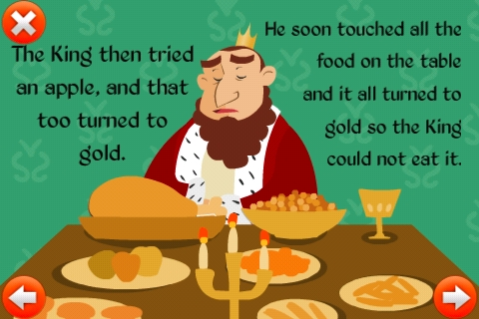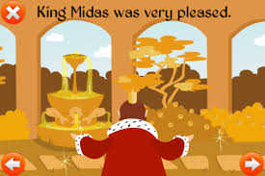

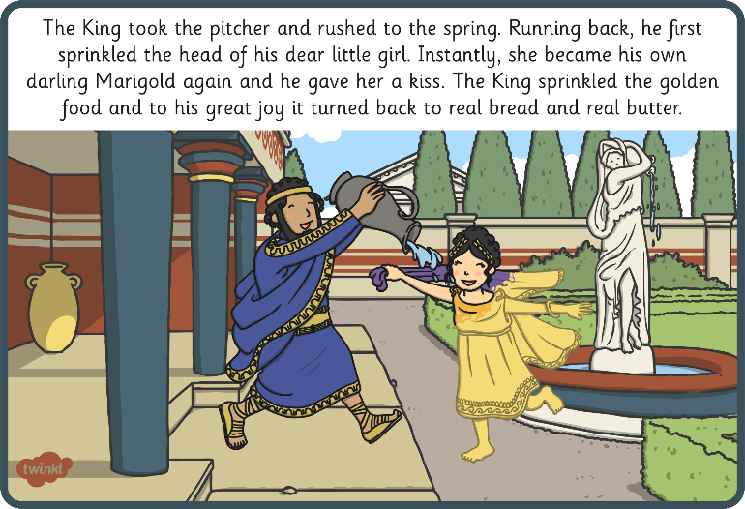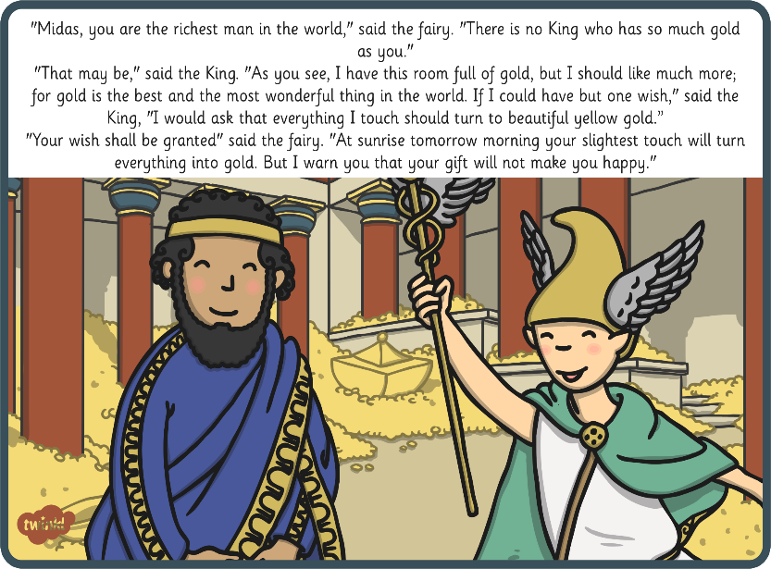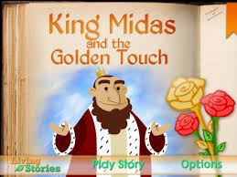

King Midas realised he was wrong and asked the Fairy to take back his wish and save his daughter! He was never greedy again.

One day, he met a genie and King Midas asked the Fairy to make everything he touched turn to gold!

King Midas was a very greedy man.

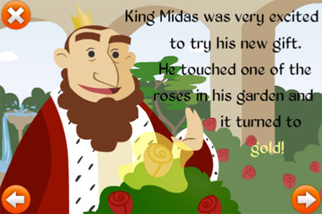

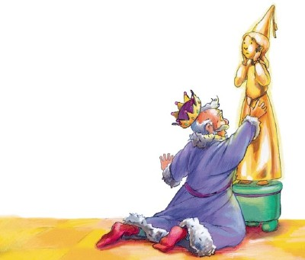

The king tried to hug his daughter but she turned to gold too!

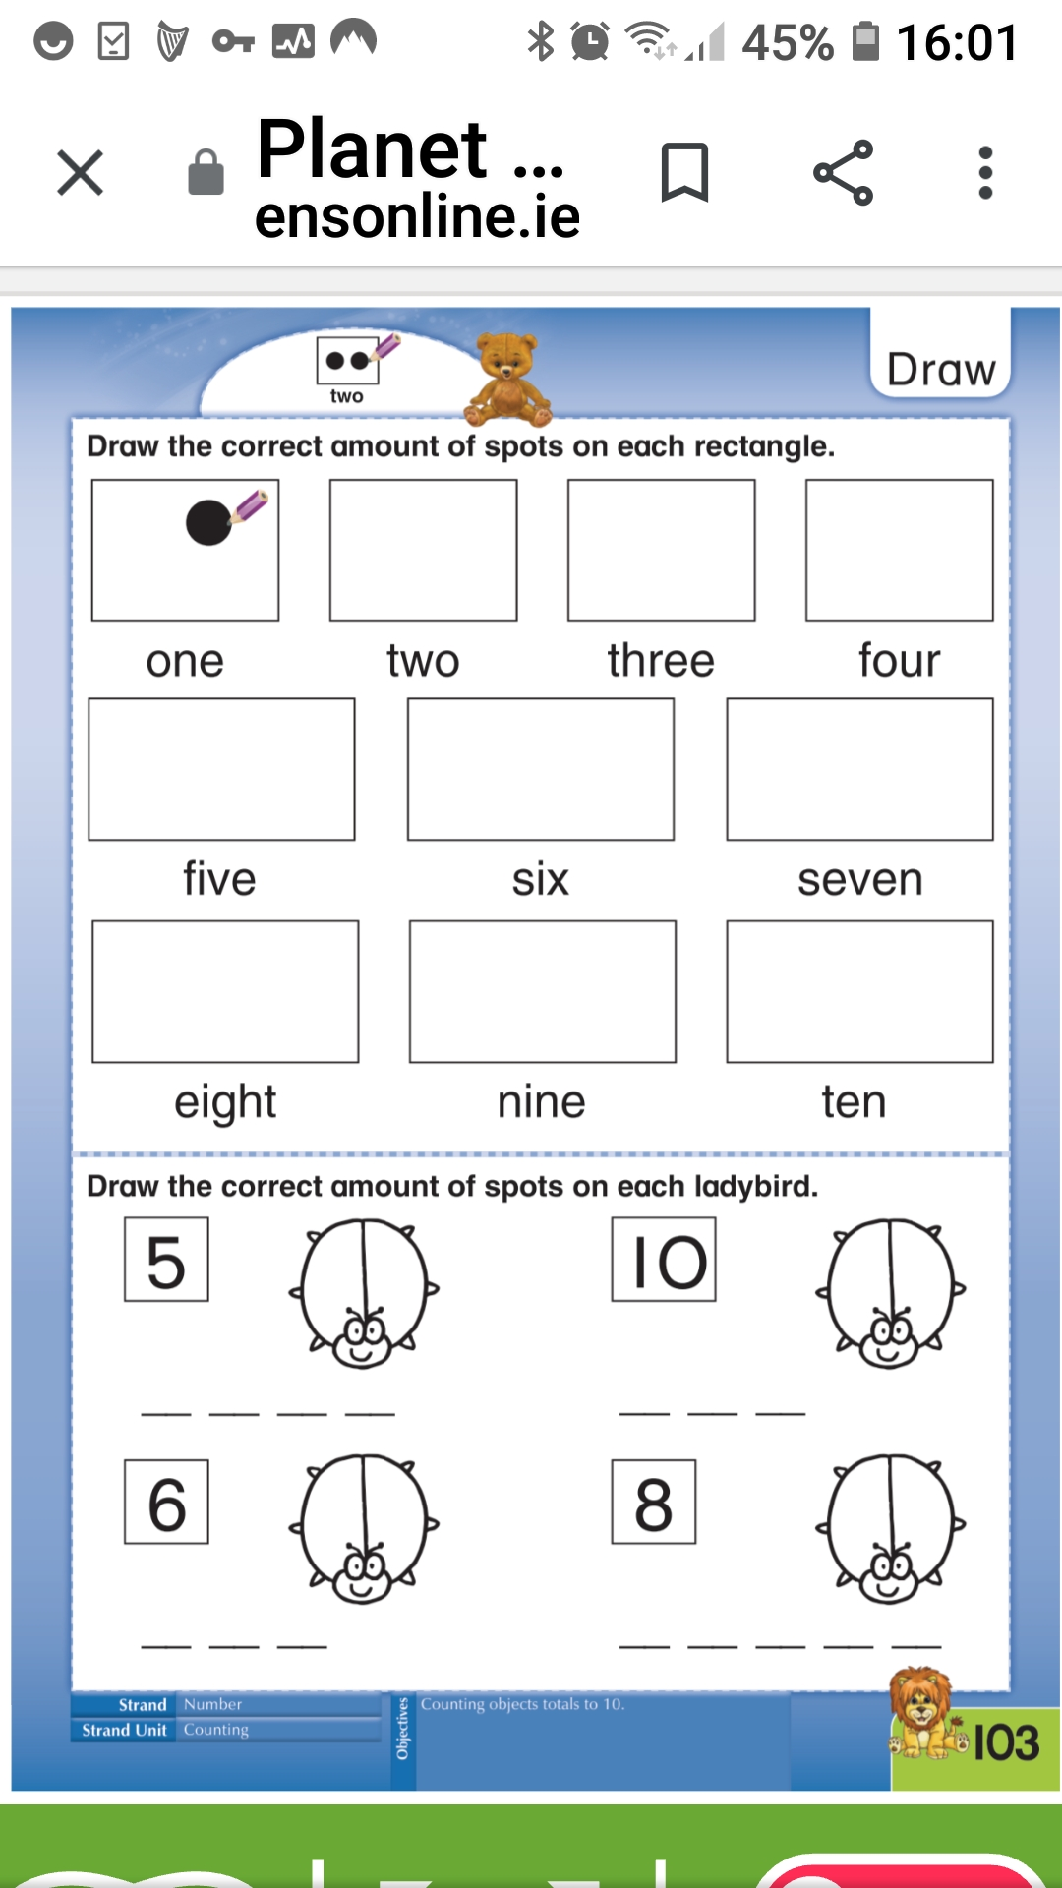

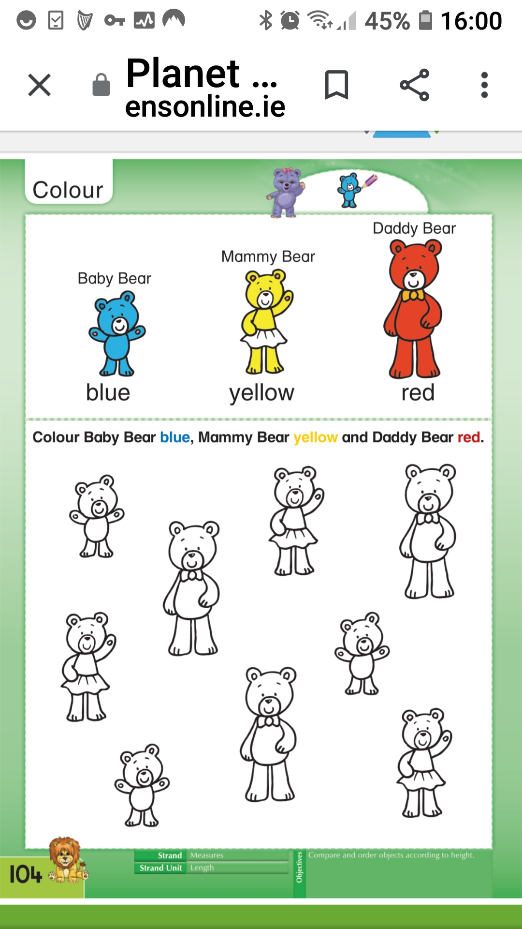

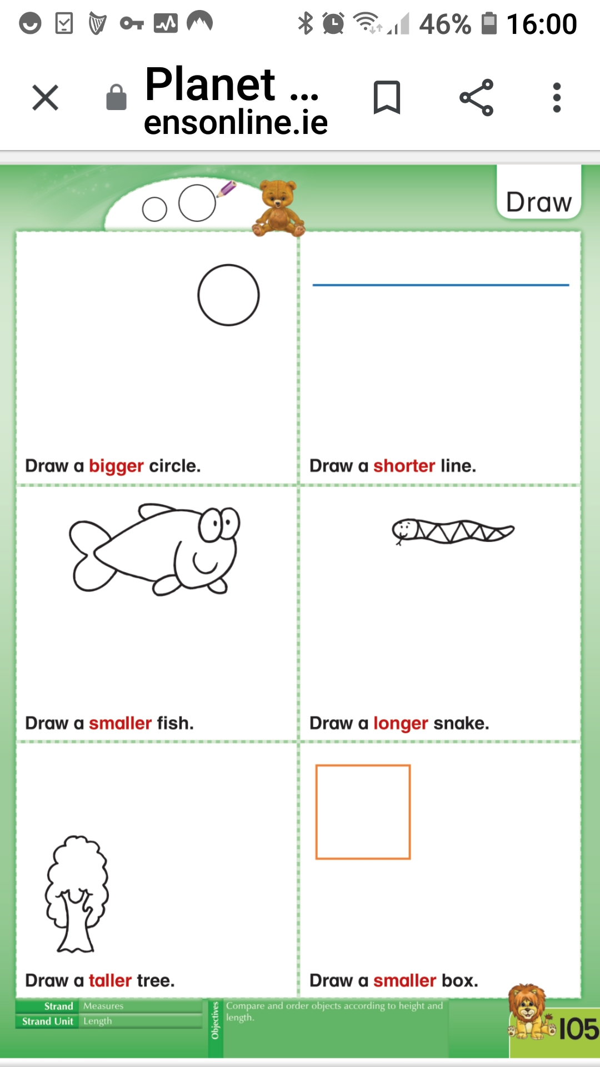

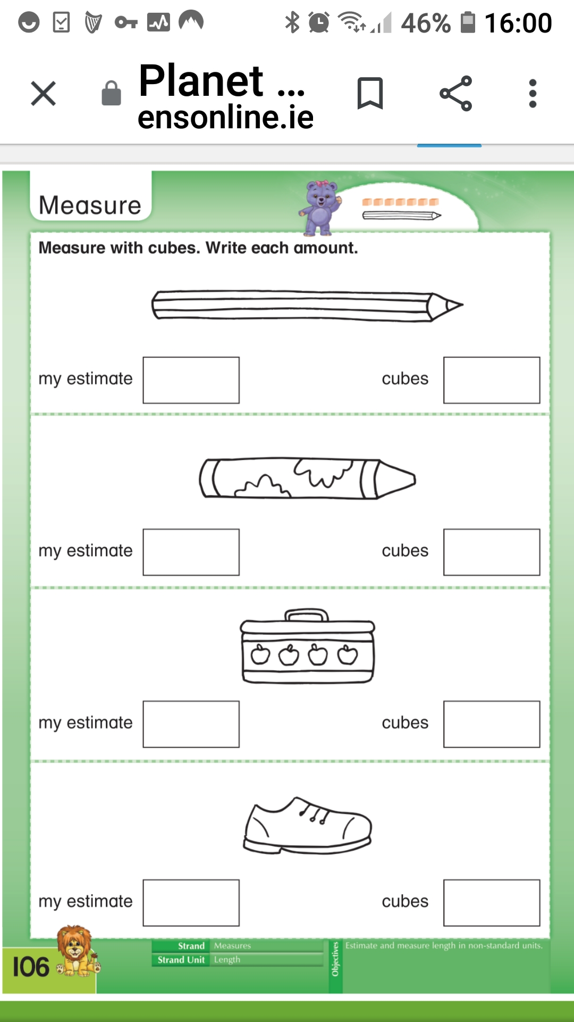

King Midas was a very greedy man.