- This work is simply a menu from you to choose work from. There is no pressure to complete this work. It is simply to provide ideas for you if you have time.
- Find what works best for your family in the current situation. A small amount of quality positive learning is more beneficial than a long period of frustration.
- Exercise and play are equally important for your child’s development so try to include these on a daily basis.
- We have focused on English and Maths as we feel it will be best to focus on these two key areas.
- Carry on with your assigned homework if possible.

Maths
Have a go at the mental Maths questions. What is your score out of ten?

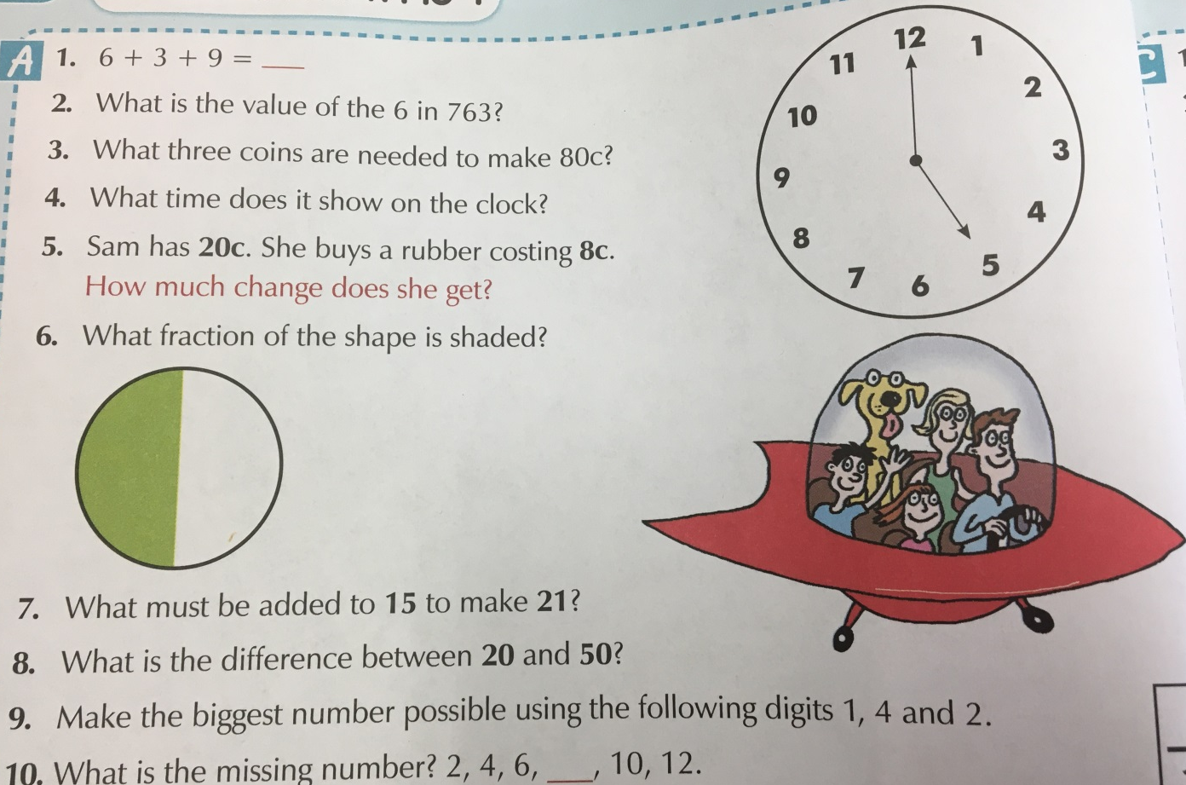

This week our focus is subtraction. Have a go at these questions:

Read these word problems carefully. Look for key information.

Reading
Remember that it is really important to read a few pages of your home reader each day.

This is our VIPERS text we will be exploring together this week in class.
Have a go at completing this reading comprehension.
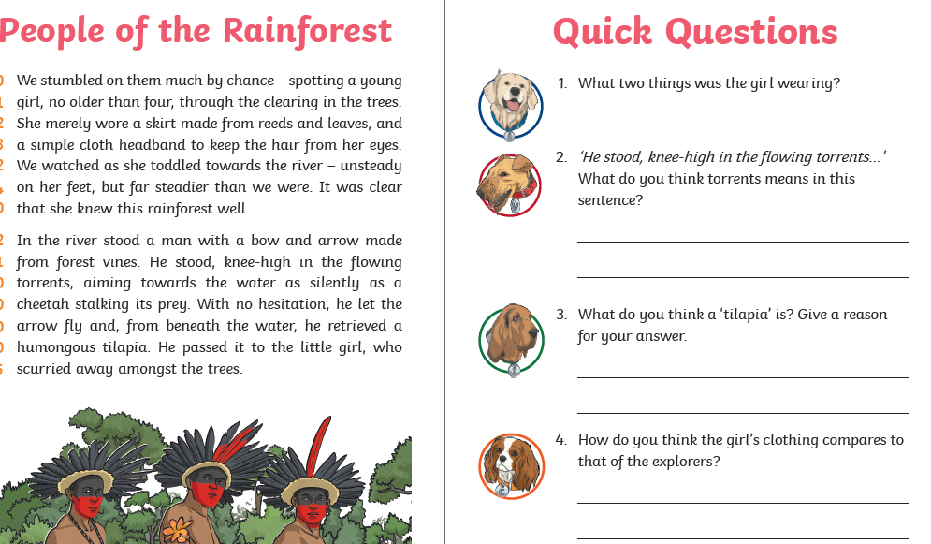

Writing
This week we will be finishing our recounts. We will be using adventurous adjectives to make our writing more interesting.

