Week- May 18th– May 22nd India Class
Any questions please contact colm@lucaneastet.ie or fiona@lucaneastet.ie
- This work is simply a menu from you to choose work from. There is no pressure to complete this work. It is simply to provide ideas for you if you have time.
- Find what works best for your family in the current situation. A small amount of quality positive learning is more beneficial than a long period of frustration.
- Exercise and play are equally important for your child’s development so try to include these on a daily basis.
- We have focused on English and Maths as we feel it will be work best to focus on these two key areas, please let us know if you would like ideas for other areas.
- Carry on with homework per homework sheet if possible.

Day | Activity
Monday | English:  Reading: Book assigned to your individual child on getepic website-email sent with details of how to log in  Phonics: This week focus on the ch sound  Video to help introduce the sound - https://www.youtube.com/watch?v=OyrYDitif1o  Songs to help with this sound: https://www.youtube.com/watch?v=FWg2uzAuSe4  https://www.youtube.com/watch?v=D_GRbhAfhyA  Games to help with sound- https://www.kizphonics.com/phonics/digraph-ch-phonics-game/  Worksheet to help with this sound are attached below the plan.  Video to help with worksheet- http://youtu.be/ZKLtFLjF3wo?hd=1  Maths:  Use book if you have collected this from the school. Otherwise you can access the book for free online at the following link. You will need to register but this is free.  https://www.folens.ie/news-and-events/parents-teachers-get-access-to-all-our-digital-teaching-materials  Planet Maths: pg. 115- Using a number line- video explaining page- http://youtu.be/XSPPssg30vM?hd=1  Website to practice number line use- https://mathsframe.co.uk/en/resources/resource/37/placing_numbers_on_a_number_line  Optional:  - PE with Go Noodle- https://www.youtube.com/watch?v=9xng62RWa_k  - Can you learn the milkshake song?  https://www.youtube.com/watch?v=dNL6RwymoNg
Tuesday | English:  Reading: Book assigned to your individual child on getepic website. App is available  High Frequency Words revision: Revise these words:  Fell, find, from, gave, girl, going  Vocabulary work:  Can you write each word three times?  Look at the word, cover it, then write it.  Can you play a game of bingo with someone at home with these words?  Maths:  Planet Maths: pg. 116- This page focuses on 3D shapes and counting  Game to help with counting- https://www.topmarks.co.uk/learning-to-count/teddy-numbers  Song to help with 3D shapes- https://www.youtube.com/watch?v=guNdJ5MtX1A  Video to help with page- http://youtu.be/cYclWrSXm6c?hd=1  Optional:  Gaeilge: Spórt (sport) - some games and songs the children should know from school  https://content.folensonline.ie/programmes/AbairLiom/SI/resources/Poster/AL_SI_ACT_Postaer_L10_001/index.html
Wednesday | English:  Reading: Book assigned to your individual child on getepic website.  Writing : Writing a thank you card-  Can you write a thank you card to someone in the health service, the Taoiseach, the chief medical officer or someone you know who works on the front line.  You could mention-  -What you are doing to stay safe in lockdown?  -What have you been doing to stay busy?  Maths:  Planet Maths: pg. 117- This page focuses on 3D shapes and counting  Song to help with counting 1-20- https://www.youtube.com/watch?v=D0Ajq682yrA  Kahoot Quiz to help with 3D shapes - https://kahoot.it/challenge/03619698?challenge-id=b2362518-d3e7-4ecd-8c50-a7f2ee02ff8b_1589380692348  Click on the link above to take the 3D shape quiz and see how well you know your 3D shapes  Video to help with page- http://youtu.be/cYclWrSXm6c?hd=1  Optional:  Geography- Keeping Safe in the Sun-  - How do we keep safe in the sun?  - Why is the sun dangerous?  - Use the worksheet at the bottom of the page and draw in what you need to keep safe in the sun. Will you need a hat? Sun cream? What else could keep you safe in the sun?
Thursday | English:  Reading: Book assigned to your individual child on getepic website.  Revise it words- sit, split, bit, fit, pit, kit  Kahoot Quiz game on it words: Click on the link and see can you get the top score! The challenge is to find all the ‘it’ words.  https://kahoot.it/challenge/0831491?challenge-id=b2362518-d3e7-4ecd-8c50-a7f2ee02ff8b_1589368557911  Maths: Page 118- Video to explain the page- http://youtu.be/sB0i6Ou6488?hd=1  Game to focus on ordering and sequencing- https://www.topmarks.co.uk/ordering-and-sequencing/caterpillar-ordering  Optional:  Music: Song about the Sun, Moon and Stars  https://www.youtube.com/watch?v=vcUyDAO1Fk0
Friday | English:  Reading: Book assigned to your individual child on getepic website.  Writing: Next 2 pages of small Just Handwriting practice book as per homework sheet. If this book is complete, then 1 page from Just Handwriting (big class book).  Maths: Next two pages of small planet maths practice book.  Optional:  Art  Drawing a Sun: https://www.youtube.com/watch?v=VgVhLWPyP5g

Resources:
Optional activities :
Padlet: https://padlet.com/fiona42/ouck8emw771r or https://padlet.com/colmsmyth/wjl4vz6b3cs7
Gaeilge:
Abair Liom is available to download at home. This gives full access to the Gaeilge programme with games, activities and stories.
To access Abair Liom’s interactive programme at home, for a limited period, please follow the instructions below.

- Go to https://www.folensonline.ie/home/library/programmes/abair-liom-senior-infants/resources/
- Select Teacher
- Fill in a username, email and password
- For Roll Number use the code :Prim20
The login details below can be used for all class levels.

Reading:
Oxford Owl offer ebooks online. I have set up a class login to access these books
Website: https://www.oxfordowl.co.uk/
Click Class Login: User Name: Lucan East Password: Senior Infants

Rainy Day Physical Education:
- Gonoodle.com (guided dance, meditation, stretching, workouts)
- Cosmickids.com (yoga, mindfulness meditations)
- Joe Wicks has a daily PE workout on at 9am on social media platforms

Local GAA clubs and other sporting clubs are putting up plenty of sports and exercise related activities on their own webpages and social media pages.

SESE: (History Geograpy Science)
World Book Online: This has a section dedicated to children. It has age appropriate texts and information and is ideal for project work. The kids section rather than the student section is most appropriate for second class pupils.
World Book online via Scoilnet https://www.scoilnet.ie/scoilnet-services/world-book/
Twinkl .ie have given a free subscription to parents and school which has a multitude of worksheets available for all class levels. Go to twinkl.ie/offer and enter the code IRLTWINKLHELPS

Other Websites of Interest:
Scratch Junior (app or website): This is a coding programme for children and it is highly recommended in education circles in order to develop STEM and computational thinking skills. There are some ‘getting started’ video lessons on their website but to be honest I have found children are very quick at picking up how to write the code. This is an excellent educational and creative programme for a rainy day that your daughter could engage with independently.
Scratch Junior Video Guides : https://www.scratchjr.org/teach/activities
While I am very conscious that as parents we don’t want our children looking at screens for long periods of time, this programme is good as the children are creating their own content and using problem solving skills. They are creating content rather than consuming it.

Maths: Topmarks.com – has a selection of games for primary aged pupils. For example: https://www.topmarks.co.uk/maths-games/hit-the-button
Planet Maths is available to download at home. This gives full access to the Maths programme with games, activities and stories.
To access Planet Math’s interactive programme at home, for a limited period, please follow the instructions below.

- Go to folens online
- Select Teacher
- Fill in a username, email and password
- For Roll Number use the code :Prim20
The login details below can be used for all class levels.

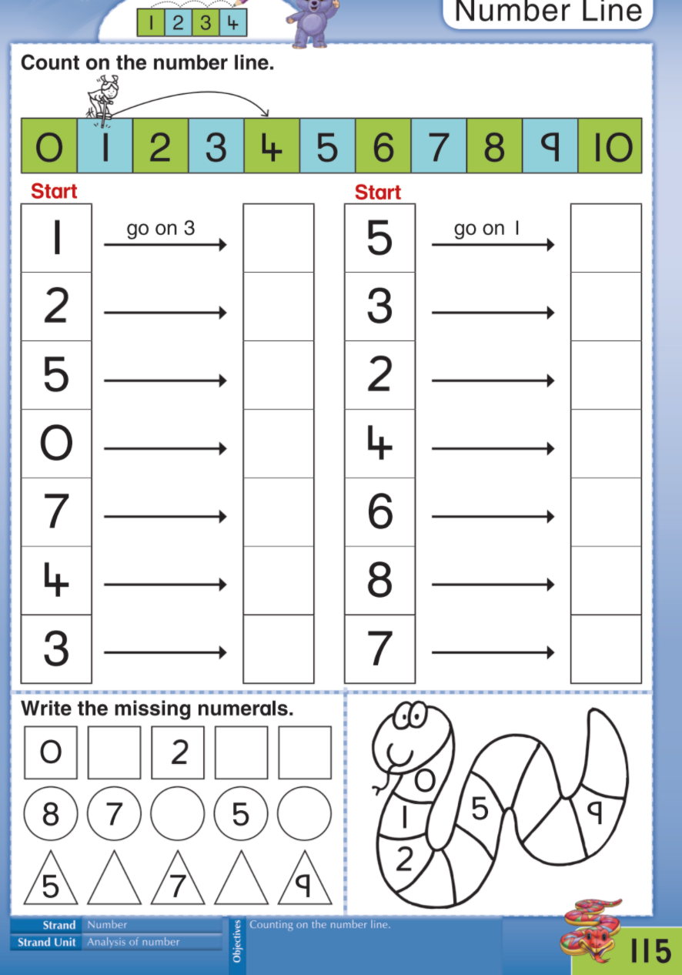

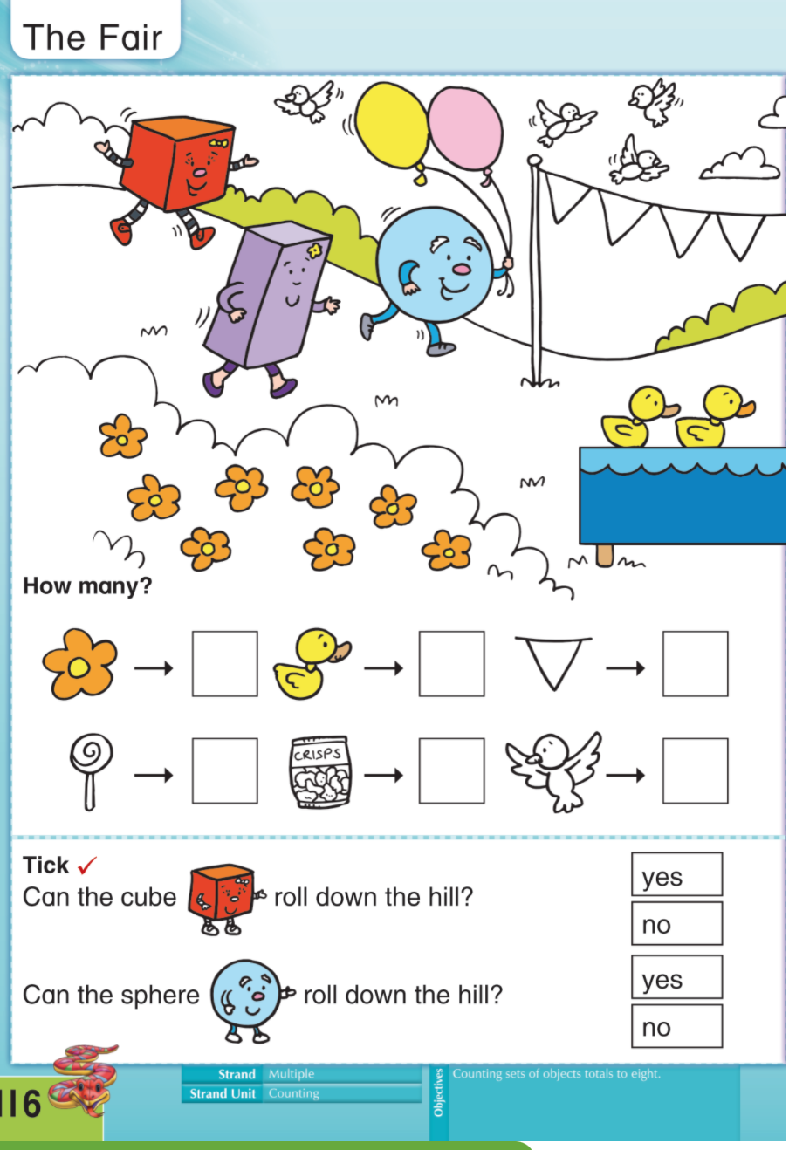

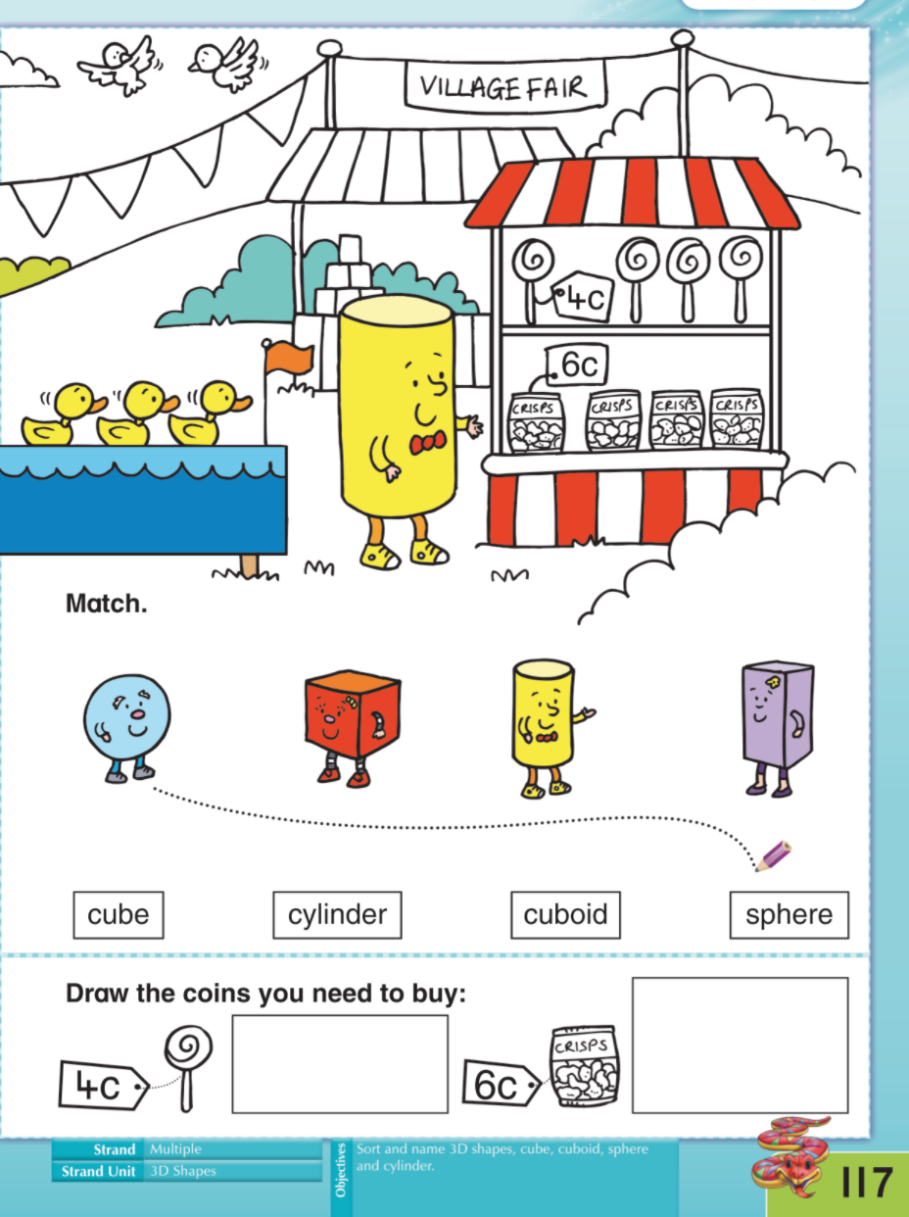

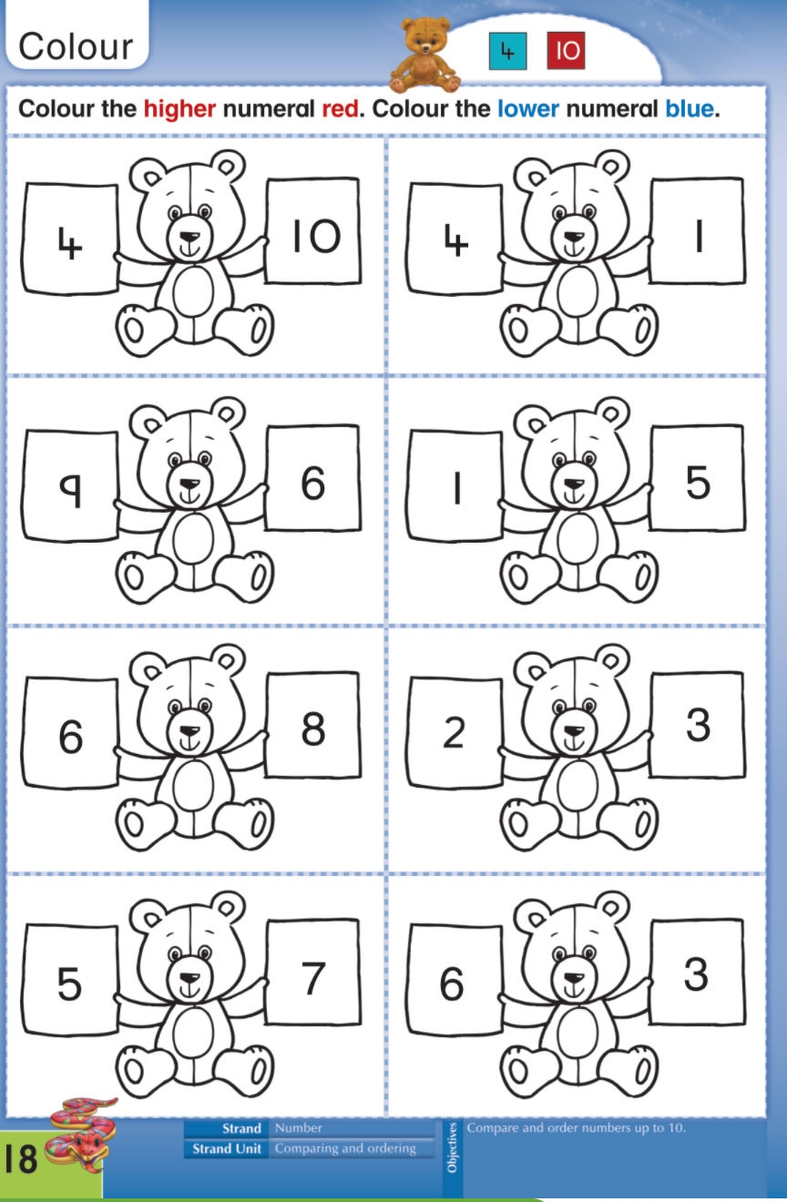
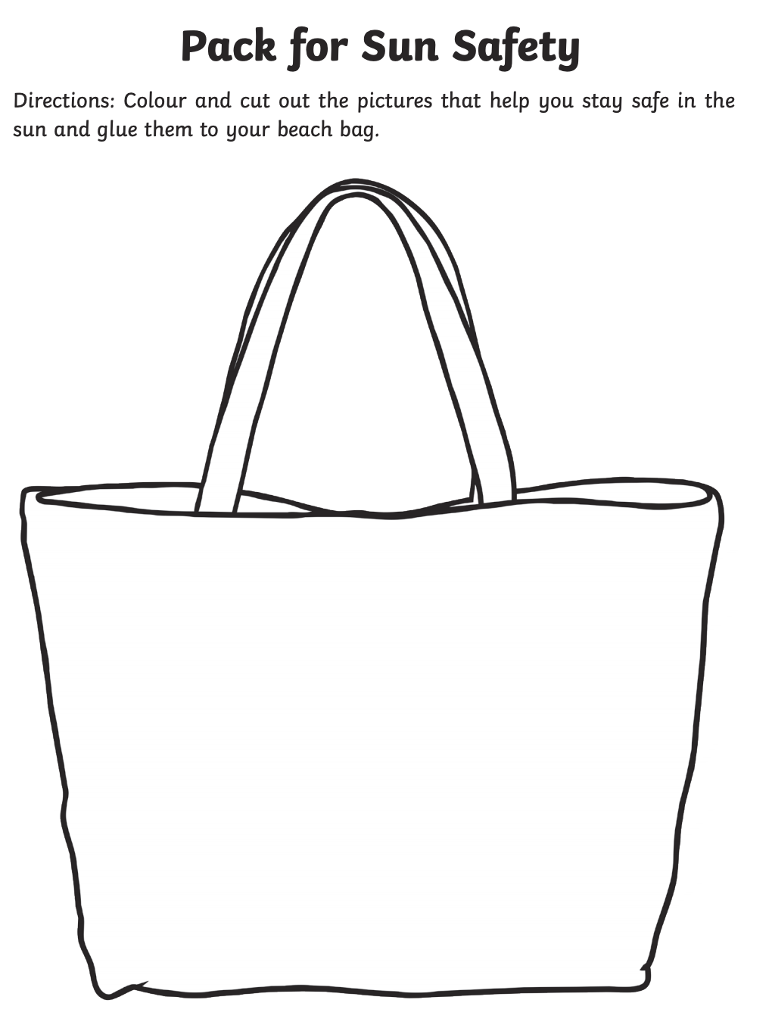

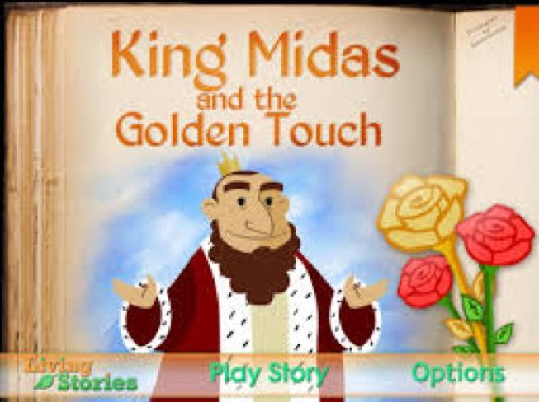
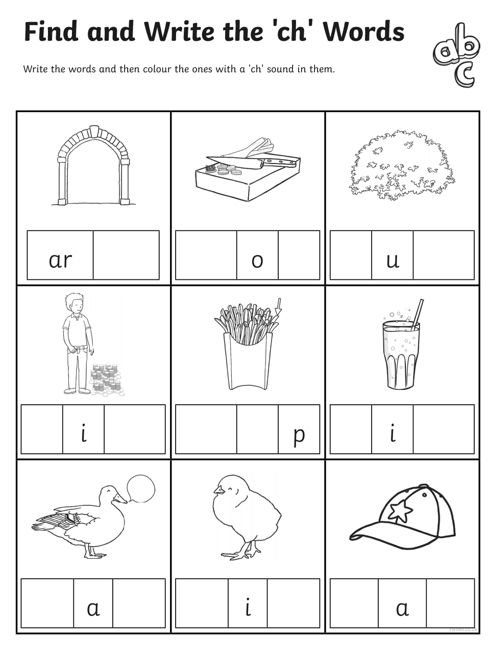
King Midas was a very greedy man.

