5th Class 21st to 25th September

English | - Spellbound Week 4  - Cloze exercise (below)  - Reading comprehension (below)  - Recount. Use the table below to write a recount of their weekend.
Maths | - Revise 6,7,8 and 9 times tables  - Mathemagic pages 12, 13, 14, 15 & 16 are being done in class this week.
Irish | - Ceartlitriú Lth 1, 2 &3

Reading comprehension
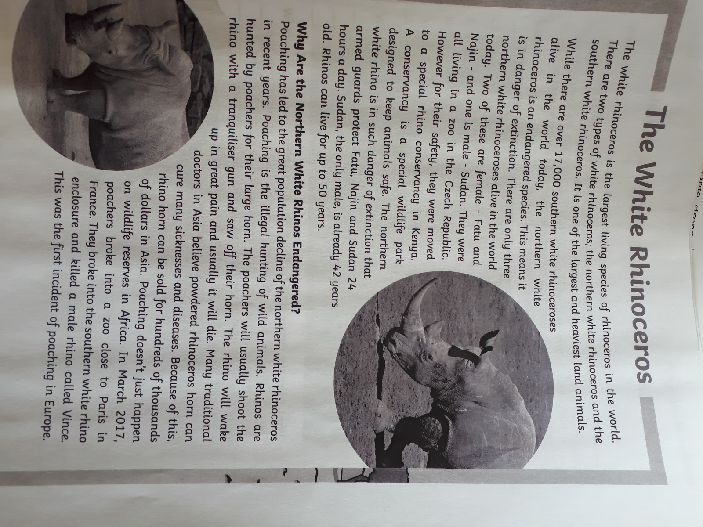
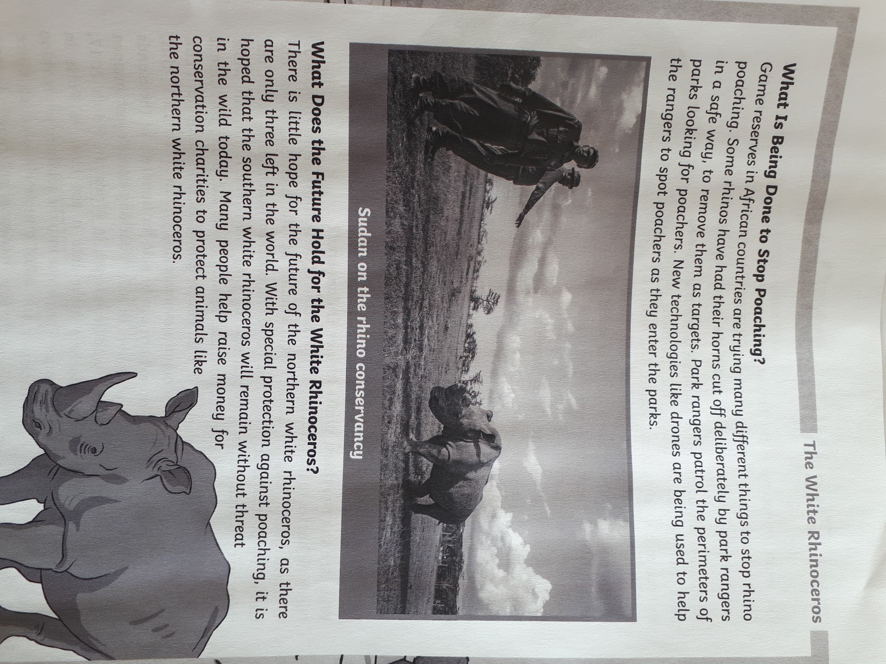

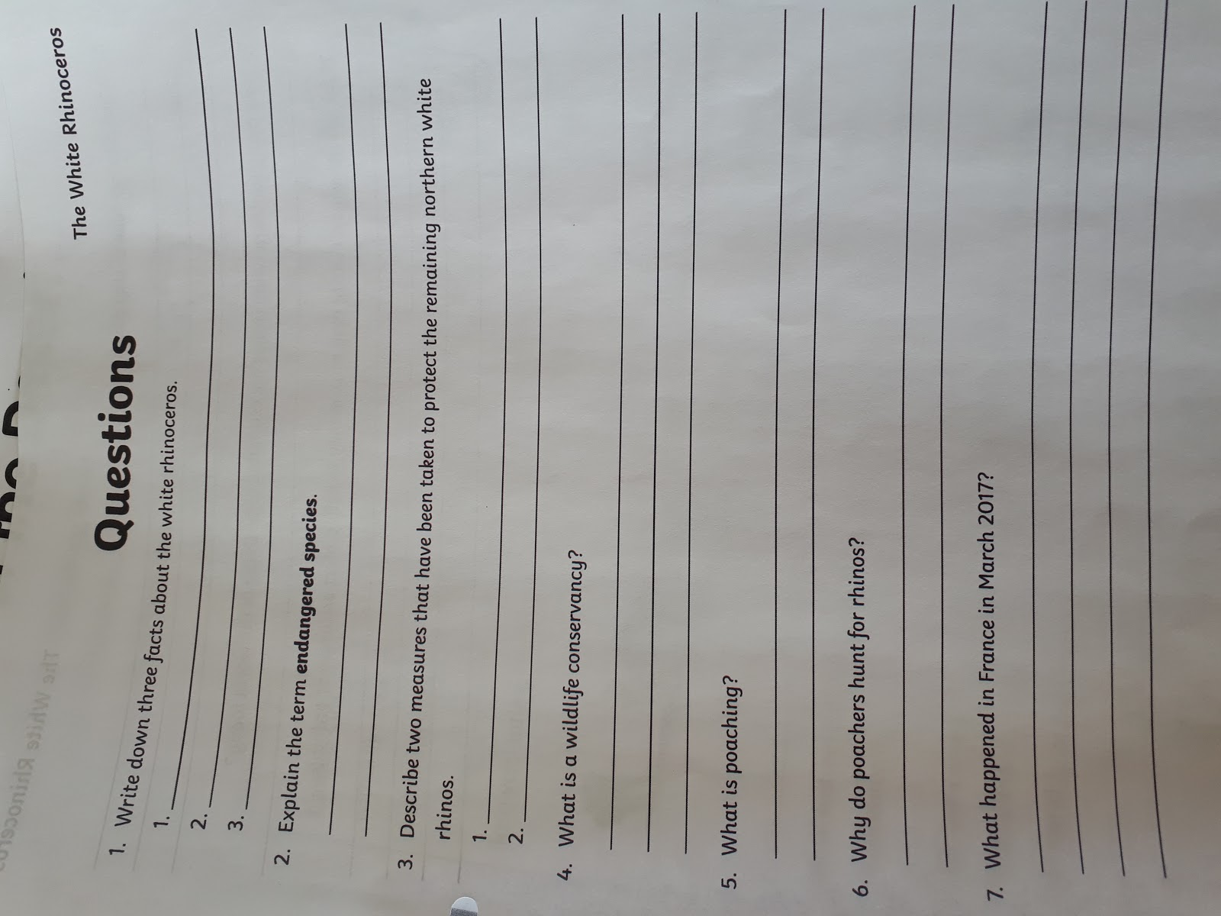

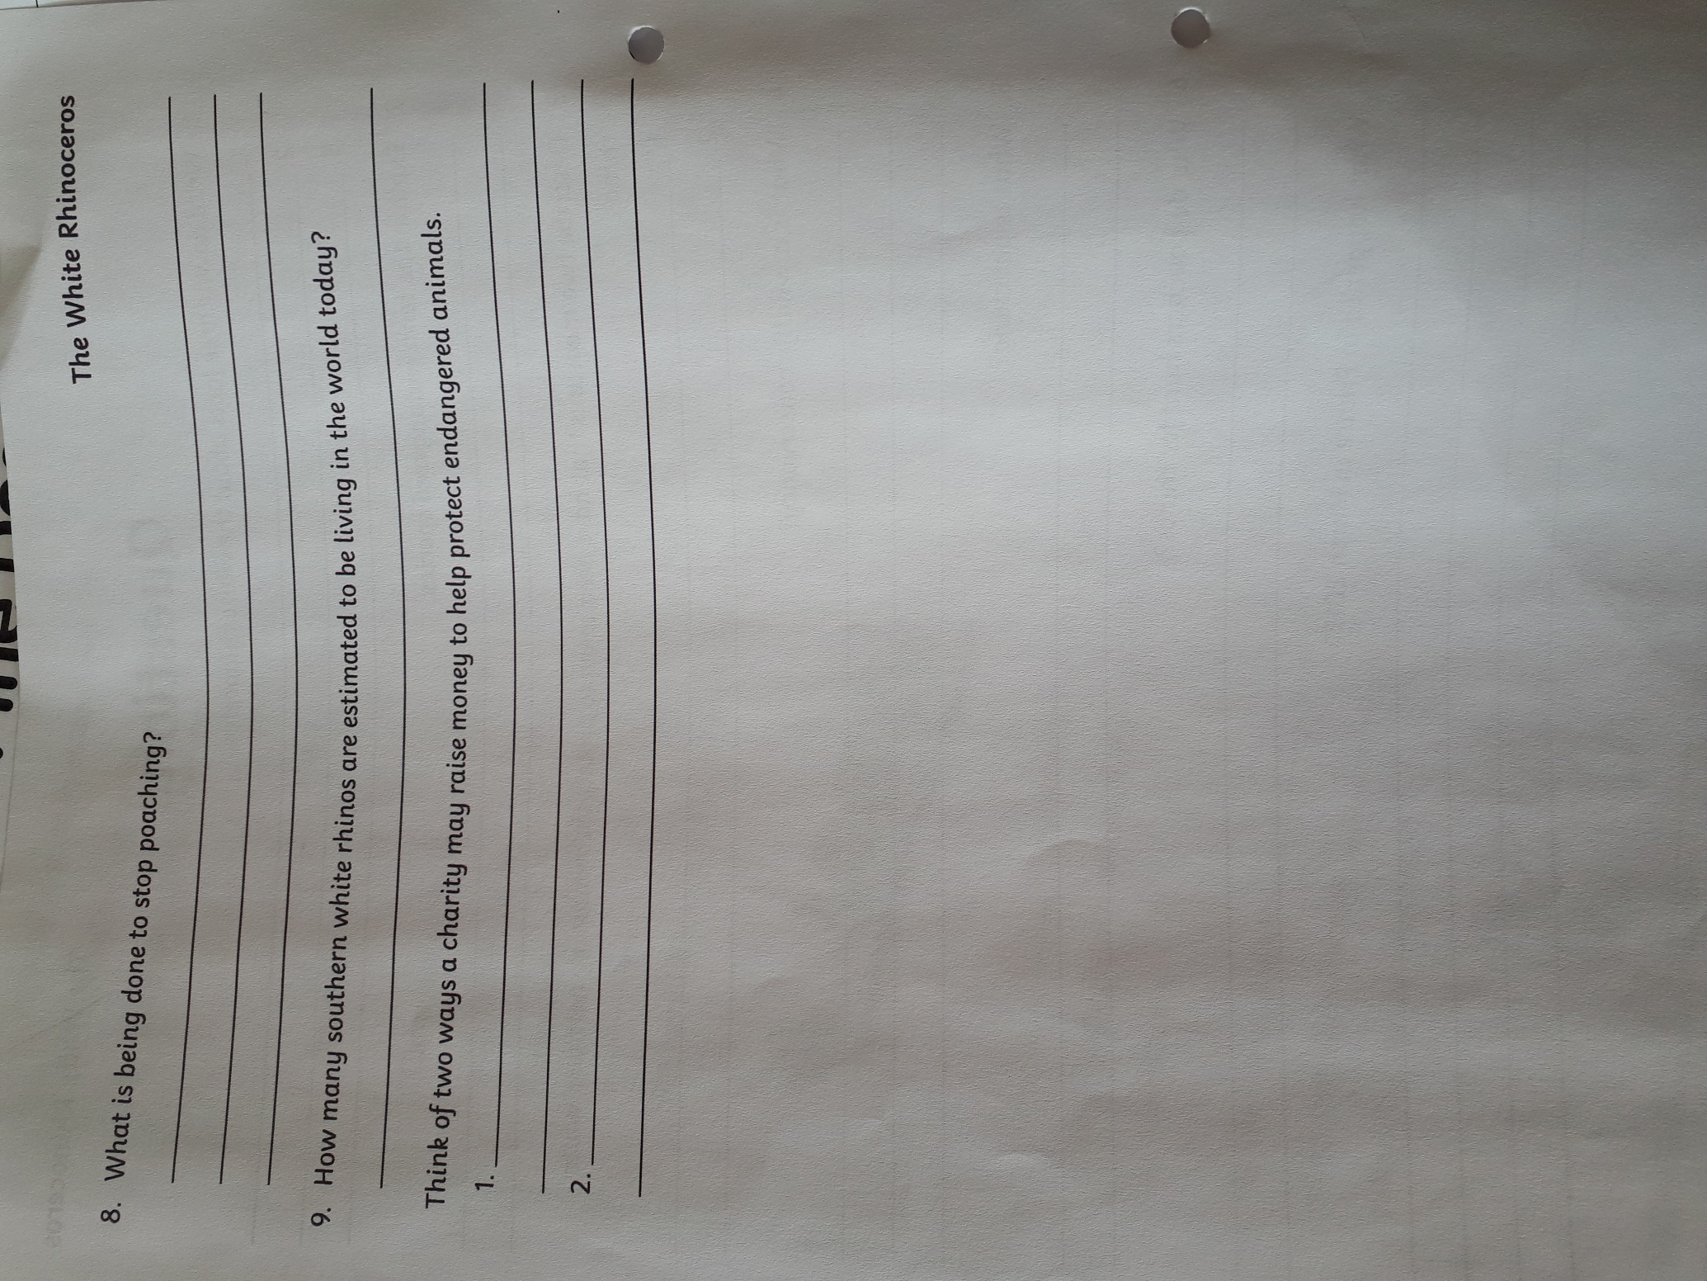

Cloze procedure
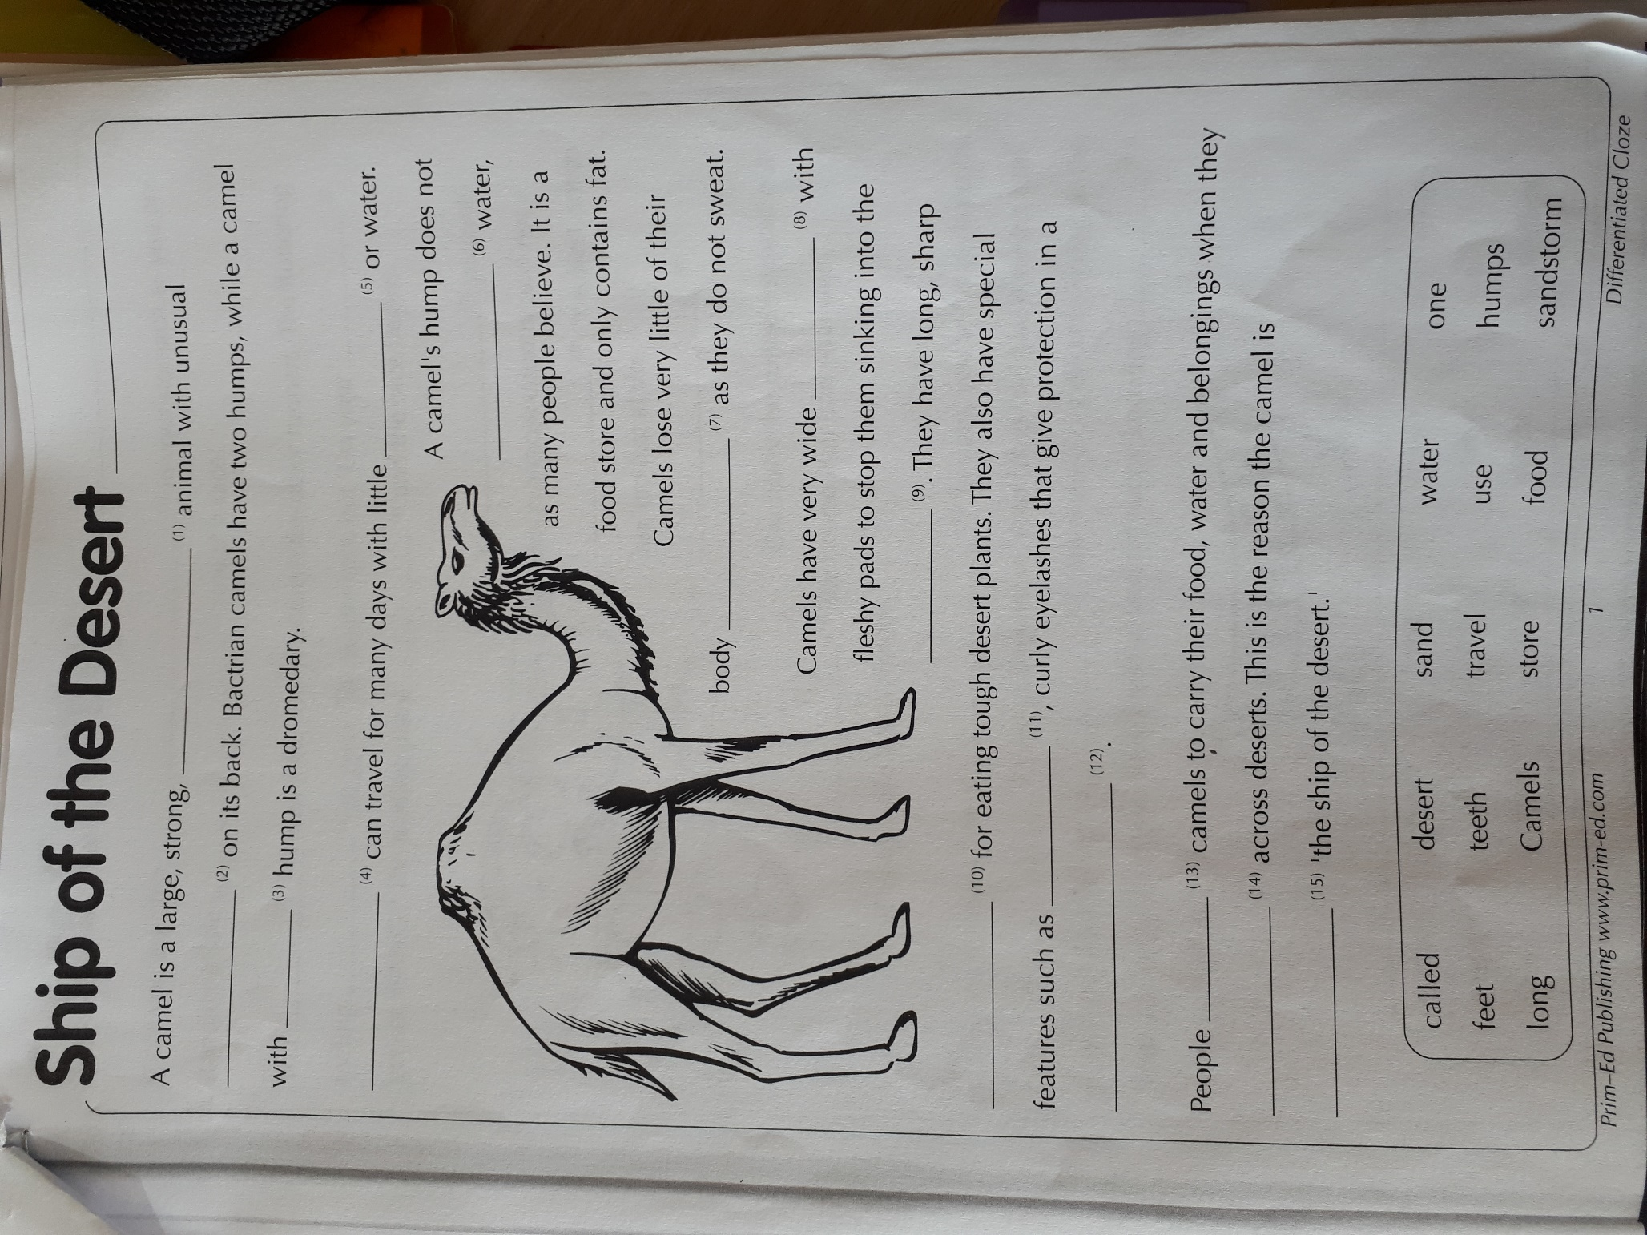

Recount template
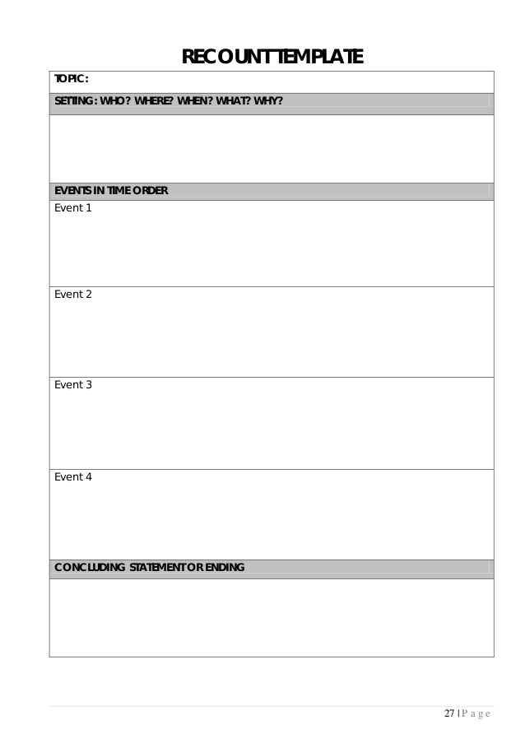

Maths
